MAWTS-1

## EAGLE-03

## MAWTS-1 Academic Standards,

## Processes and Procedures

Effective as of July 2021

INSTRUCTOR GUIDE

This Page Intentionally Left Blank

Table of Contents

|  |  |  |  |  |  |  |  |
| --- | --- | --- | --- | --- | --- | --- | --- |
| MAWTS-1 ACAD Overview / CRC | | | | | | | ….…………………4 – 5 |
| WTI Milestones and Facilities | | | | | | | ….…………………6 - 8 |
| MAWTS-1 ACAD Products | | | | | | |  |
|  | Appendix G | | | | | | ……………………8 - 9 |
|  | Course Catalog | | | | | | …..…..…………...9 - 10 |
|  | Graphics libraries and multimedia support | | | | | | ………………….10 - 11 |
|  | WTI Read Ahead Materials | | | | | | ………………… 11 - 12 |
| Courseware | | | | | | |  |
|  | Locations | | | | | | ………………….13 - 14 |
|  | Revising and Maintaining existing courseware | | | | | | ……………….....……14 |
| Courseware submission process | | | | | | |  |
|  | | | | Unclassified | | | ………………….14 - 15 |
|  | | | | Classified | | | ……………………….15 |
|  | | Creation of new courseware | | | | |  |
|  | | | | | Standardization | | ………………….……16 |
|  | | | | | Courseware design guidance | | ……………………….17 |
|  | | | | | Format | |  |
|  | | | | | | Unclassified | ………………….17 – 24 |
|  | | | | | | Classified | …….……………24 - 27 |
|  | | | Classification information | | | | ………………….28 – 34 |
|  | | | Development of Learning Objectives | | | | ………………….35 – 37 |
| Media naming conventions | | | | | | | ……………………….38 |
| Instructional Standards | | | | | | |  |
|  | | | Murderboards | | | | ………………….38 – 40 |
|  | | | Evaluation Policies and Design | | | | ………………….40 – 44 |
|  | | | MAWTS-1 Evaluation Products | | | | ………………….45 – 48 |
| Guest speakers | | | | | | | ………………………48 |
| Student Critique template | | | | | | | ………………………49 |
| Additional Resources | | | | | | |  |
|  | | | Learning theory | | | | ……………………….51 |
|  | | | Systematic Approach to Training (SAT) | | | | ………………….52 – 55 |
|  | | | Test design research | | | | ………………….56 – 58 |
| References | | | | | | | ……………………….60 |

|  |
| --- |
| MAWTS-1 Academic Standards, Processes and Procedures |
|

* 1. **Overview.**  This document describes the process through which Instructors, in concert with the Academics Department, prepare for the Weapons and Tactics Instructor (WTI) course. It also describes, in depth, the academic standards for MAWTS-1 courseware, including WTI and ASP courses, as set forth in Squadron Order 1550. Procedures, documented and implemented, support this mission.
  2. **Curriculum Review Committee.** The Curriculum Review Committee (CRC) is central to the entire academic process at MAWTS-1. It provides recommendations to the Commanding Officer regarding nearly all aspects of the MAWTS-1 academic program, to include standards, content, examinations, and scheduling. The CRC will regularly review the program of instruction and determine the suitability of read ahead material, generic, and common courseware for WTI Course, Academic Support Package (ASP) and any other courseware associated with MAWTS-1, such as Commander’s Course and Reblack. The CRC’s main emphasis is to ensure that the academic syllabus remains comprehensive, relevant, and current.
     1. **CRC Membership.** The Academic (ACAD) Department Head chairs the CRC. Department Heads are generally members of the CRC, unless the delegation is passed on from the Department Head to an assigned Department representative, with approval from the ACAD Department Head. Other members include Academics department members, including the COMCAM Officer, and General Dynamics Instructional Technology employees, contracted to support the Academics package.
     2. **CRC Responsibilities**. The CRC will review the WTI and ASP academic syllabi (Generic and Common), evaluate possible revisions to the curriculum, consider proposals for new courseware, and monitor the progress of instructors revising or developing courseware. The specific responsibilities of the committee that pertain to the WTI course are as follows:
* Determine the overall objectives and emphasis of the Generic and Common academics
* Conduct a detailed review of the academic syllabus after each WTI course
* Recommend and prioritize revisions to the curriculum
* Evaluate established courseware for currency and applicability to the WTI course
* Review and recommend WTI Generic and Common course primary and alternate instructor assignments/replacements
* Evaluate new courseware proposals as submitted and provide direction to the instructor during courseware development
  + 1. **CRC Schedule.** The Commanding Officer (CO) sets the CRC schedule. At a minimum, the CRC will meet during the WTI *Hot Wash* and once during each *Freeze Week*. During *Hot Wash*, the CRC will review and recommend changes to the academics as taught in the recently completed WTI course. This may include course revisions, additions, deletions, or schedule changes. Based on critiques, IP input, and the CRC desires, recommendations for changes for the next WTI course are presented to the CO. Updates to the CO will be presented each *Freeze Week*, as required. Based on the CO’s guidance, at the completion of the *Hot Wash*, the CRC will publish a listing of dropped, revised, and new classes for the next WTI. This listing will include guidelines and/or deadlines for instructors assigned to revise or create new courses.

**1.2.3.1. Revised Classes**. If the CRC should propose changes to an existing course, it will specify those areas needing requisite changes. The committee will then establish a deadline (e.g. 4 weeks) for submission of those changes for review by the Academics Department and the CRC.

**1.2.3.2. New Classes**. Any instructor may submit concepts for a new class. Once a new class has been approved by the CRC, the class will be assigned to an instructor. The CRC will then establish a deadline (e.g. 2 weeks, but no later than 1st Freeze) for submission of the Purpose Statement and Learning Objectives to support the proposed course. Once the CRC has reviewed the summary of the course and has agreed upon the content, it will establish a new deadline (6 weeks) for submission of final text and course materials to the Academics Department. Final review of the new course material will be the responsibility of the Department Head and the instructor. The review will include proofreading text and presentations, as well as a Murderboard, to determine that the content and delivery of the course meets MAWTS-1 standards.

**1.2.3.3. Specific Courseware**. Considerations regarding Specific courses are not required by the CRC. Review of those courses will be the responsibility of the appropriate department and/or division heads.

**1.2.3.4.** **Primary and Alternate Instructor Assignment**. Each course will have a primary and alternate instructor. The CRC will recommend primary and alternate instructors for generic courses only. *Note. First year instructors will not teach Generics courses. Exceptions to this will be approved by the CO, on the recommendation of the Academics Department Head, on a case-by-case basis.* Department heads will recommend Common and Specific instructor assignments. A master list of primary instructor assignments for all classes is maintained by the Academics Department via Appendix G. Ideally, the CRC will consider instructor substitutions two courses in advance for WTI courseware. This will enable the new instructor to observe the course for one WTI rotation before assuming responsibility. Additionally, the CRC will consider substitutions for rotating personnel during the Spring Hot wash syllabi review.

* + 1. **CRC Summary.** The CRC provides MAWTS-1 with a method for systematically reviewing curriculum and identifying and providing guidance for necessary changes to keep the WTI course dynamic, current, and in concert with the goals of the Weapons and Tactics Training Program (WTTP).
  1. **Milestones.** Milestones are constructed in concert with the S3 Department in preparation for the WTI course. Milestones are essential for the Academic Department to prepare for the WTI class and must be rigidly adhered to in order to ensure accurate and efficient production of all WTI materials. This includes instructor identification, academic schedule generation, courseware development, WTI read ahead distribution, and guest speaker arrangements. The Academic Department Head is responsible for scheduling and adhering to applicable milestones. Each individual department head must ensure adherence to the academic milestones to insure that the quality of the WTI course will not be compromised. The Academic Department Head will monitor the milestones process closely.
     1. Key milestones that require significant instructor effort and participation include the following:
* **Murderboards**
* **First Freeze**
* **Second Freeze**
* **Third Freeze**
* **Hotwash**
  1. **Academic Scheduling.** The Academic Department, with department/division personnel, is responsible for the scheduling of all classes and the structure of the facilities to support WTI and similar courses, such as Reblack and Commander’s Course.
     1. **Academic Facilities.** Instructors or other permanent personnel can schedule the use of the BattleLab, the Heritage Room, the White Cell, Memorial Hall, Toad Hall, Conference Rooms, and libraries. Room assignments will be made by request on the “Room Reservation” drop down list on the following link on the MCEITS Academics page: https://eis.usmc.mil/sites/mawts1/acad/default.aspx

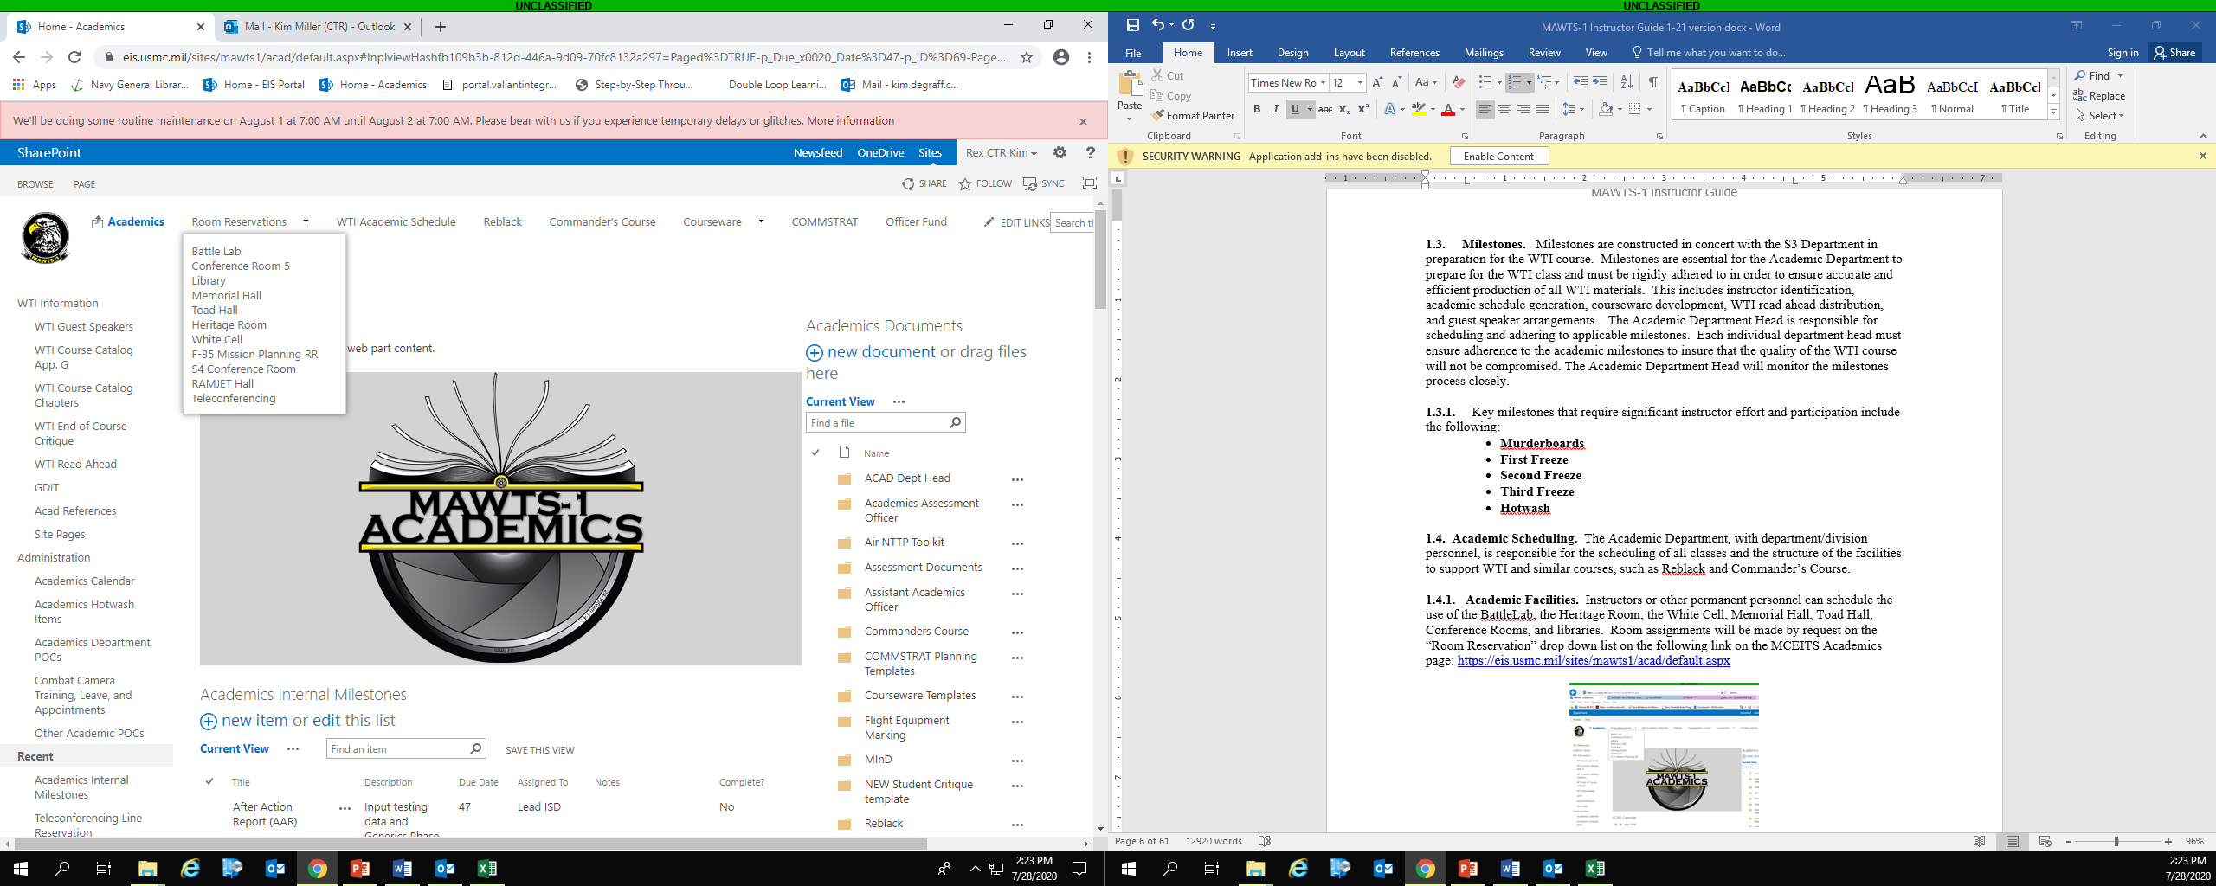

Upon completion of the academic phase, ready room scheduling will be at the discretion of the appropriate department heads.

Below are the facilities available on the “Room Reservations” drop down list. All rooms will be configured with the appropriate resources and all audio visual equipment will be checked by the Academics Department (Valiant Audio Visual) prior to its use.

* + - 1. Battle Lab
      2. Conference Room 5
      3. Library
      4. Memorial Hall
      5. Toad Hall
      6. Heritage Room
      7. White cell
      8. F-35 Mission Planning Ready Room
      9. S-4 Conference Room
      10. RAMJET HALL
      11. Other Academic Venues. Other venues on base can be scheduled for use during WTI. These venues include the Sonoran Pueblo, Infinities, base theater, and the community center. The Sonoran Pueblo can be scheduled as a whole, or subdivided into smaller classrooms for seminars or tactics discussions. *Note: Prior coordination with the Academics Department is required to configure these venues to allow for classified material up to the Secret level.*
      12. Ditto Hall. Building 508. Ditto Hall will be configured with the appropriate resources and all audiovisual equipment will be checked by the Academics Department (Valiant Audio/Visual Dept) prior to its use. *Note: Ditto Hall is not managed by MAWTS-1 and is not an open storage area. No classified material, to include secret computers, will be utilized in Ditto Hall, unless proper preparation and procedures regarding security protocols are followed.*
    1. **Academic Scheduling Process.** Academic class scheduling is a complicated process due to the large number of students and limited classroom space in Bldg. 406. Memorial, Toad, and Ditto Halls will be assigned to the class with the largest number of students, particularly during the Common and Specific phase of academics. Reference **Table 1** for a comprehensive list of rooms and their associated classroom capacities.
       1. **Academic Scheduling Timeline**. Significant effort goes into developing the academic schedule for WTI. Consideration must be given to deconflicting classroom space, instructor schedules, and eliminating courses from being taught multiple times, if it is avoidable.

|  |  |
| --- | --- |
| Venue | Capacity |
| Memorial Hall | 224 Students; 16 Eagle’s Nest |
| Toad Hall | 120 Students; 18 Crow’s Nest |
| AH-1 Ready Room Rm 12 | 15 |
| AGS Ready Room Rm 11 | 15 |
| AOD Ready Room Rm 8 | 20 |
| AV-8B Ready Room Rm 21 | 15 |
| Base Theater | 270 |
| Battle Lab Rm 135 | 25 / 15 desktop users |
| Briefing Room 16 | 4 – 6 |
| Briefing Room 17 (Secret SAP only) | 4 – 6 |
| Briefing Room 18 (Secret SAP only) | 4 – 6 |
| Briefing Room 19 (Secret SAP only) | 4 – 6 |
| C3 Ready Room Rm 10 | 40 |
| CH-53 EA Ready Room Rm 107 | 20 |
| CH-53 Pilot Ready Room 15 | 25 |
| Community Center | 80 |
| Conference Room 5 A/B | 60 |
| Conference Room 5 A only | 30 |
| Conference Room 5 B only | 30 |
| CO’s Library | 20 |
| EA-6B Ready Room Rm 22 | 15 |
| FA-18 Ready Room Rm 20 | 15 |
| F-35 Mission Planning Ready Room Rm 9 | 12 |
| GCD Ready Room Rm 7 | 25 |
| Infinities | 200 |
| INTEL Ready Room Rm 3 | 15 |
| KC-130 Ready Room Rm 4 | 25 |
| MV-22 EA Ready Room Rm 131 | 25 |
| MV-22 Pilot Ready Room Rms 14A/B | 30 |
| Heritage Room | 50 |
| Sonoran Pueblo | 400 |
| Elrod Room (Sonoran Pueblo sub-divided) | 100 |
| Boyington Room (Sonoran Pueblo sub-divided) | 250 |
| Gonzales Room (Sonoran Pueblo sub-divided) | 250 |
| UAS Ready Room Rm 167 | 10 |
| UH-1 Pilot Ready Room 13 | 20 |
| UH-1 CC Ready Room 125 | 15 |
| White Cell Rm 6 | 11 |

Table 1 - Classroom Capacities

**1.5. Academic Products.** The following academics processes and procedures are performed by the Valiant Training System Management (TSM) contractors that work in the Academics office, Room 126, and others tasked to assist in instructional support. The on-site support staff works succinctly with the Academic Department Head and the Academics Assistants to ensure a level of standardization in courseware, academic scheduling, and academics products. Details regarding courseware creation and revising and editing courseware are found in other sections of this document (see “Courseware Development”). The following is an overview of procedures and products that result from the academics process.

**1.5.1 Appendix G**. Appendix G, located on MCEITS at (https://eis.usmc.mil/sites/mawts1/acad/Lists/WTI%20Course%20Catalog%20TEST/Default%20View.aspx), is a portion of the WTI Course Catalog that is maintained and revised by Instructional System Developers (ISDs). Appendix G is a listing of the most current information for courses not included in each individual Course Catalog chapter, such as Purpose Statements, Learning Objectives, the length of courses, and classifications. This information is included in the student handouts for reference and note taking. The division, department, and/or instructor provide this information to the ISDs to record in the Appendix. If the Appendix is opened for editing by instructors and/or Academic Representatives, it will be closed prior to or during Second Freeze in order to allow the ISDs to validate the inputs prior to the content’s inclusion into the student handouts. If it is not opened to editing by staff other than the ISDs, ISDs will make the communicated changes as information is provided regarding changes, including the naming of courses or the addition or deletion of courses. Course names, instructor’s names, purpose statements, and learning objectives will be validated using submitted courseware. The length of the course, the phase, and the audience will be validated using the schedule.

Again, Purpose Statements and Learning Objectives are taken directly from the presentation. For this reason it is imperative that courseware be as up to date as possible as WTI approaches. Instructors may not have the capability to change or maintain Appendix G. Communication and accuracy of the Purpose Statements and Learning Objectives in the courseware will allow for an accurate and current product in the final version of the Student Handout.

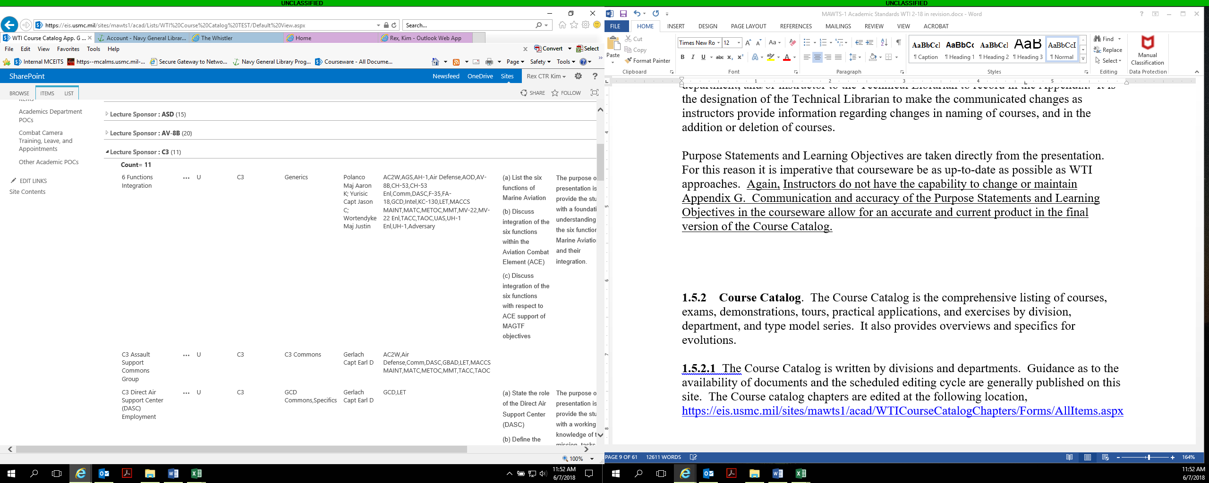

**1.5.2 Course Catalog**. The Course Catalog is the compilation of chapters that includes listings of courses, exams, demonstrations, tours, practical applications, and exercises by division, department, and type model series. It also provides overviews and specifics for evolutions.

**1.5.2.1** The Course Catalog is written by divisions and departments. Guidance as to the availability of documents and the scheduled editing cycle are generally published on this site. The Course catalog chapters are edited at the following location: https://eis.usmc.mil/sites/mawts1/acad/WTICourseCatalogChapters/Forms/AllItems.aspx

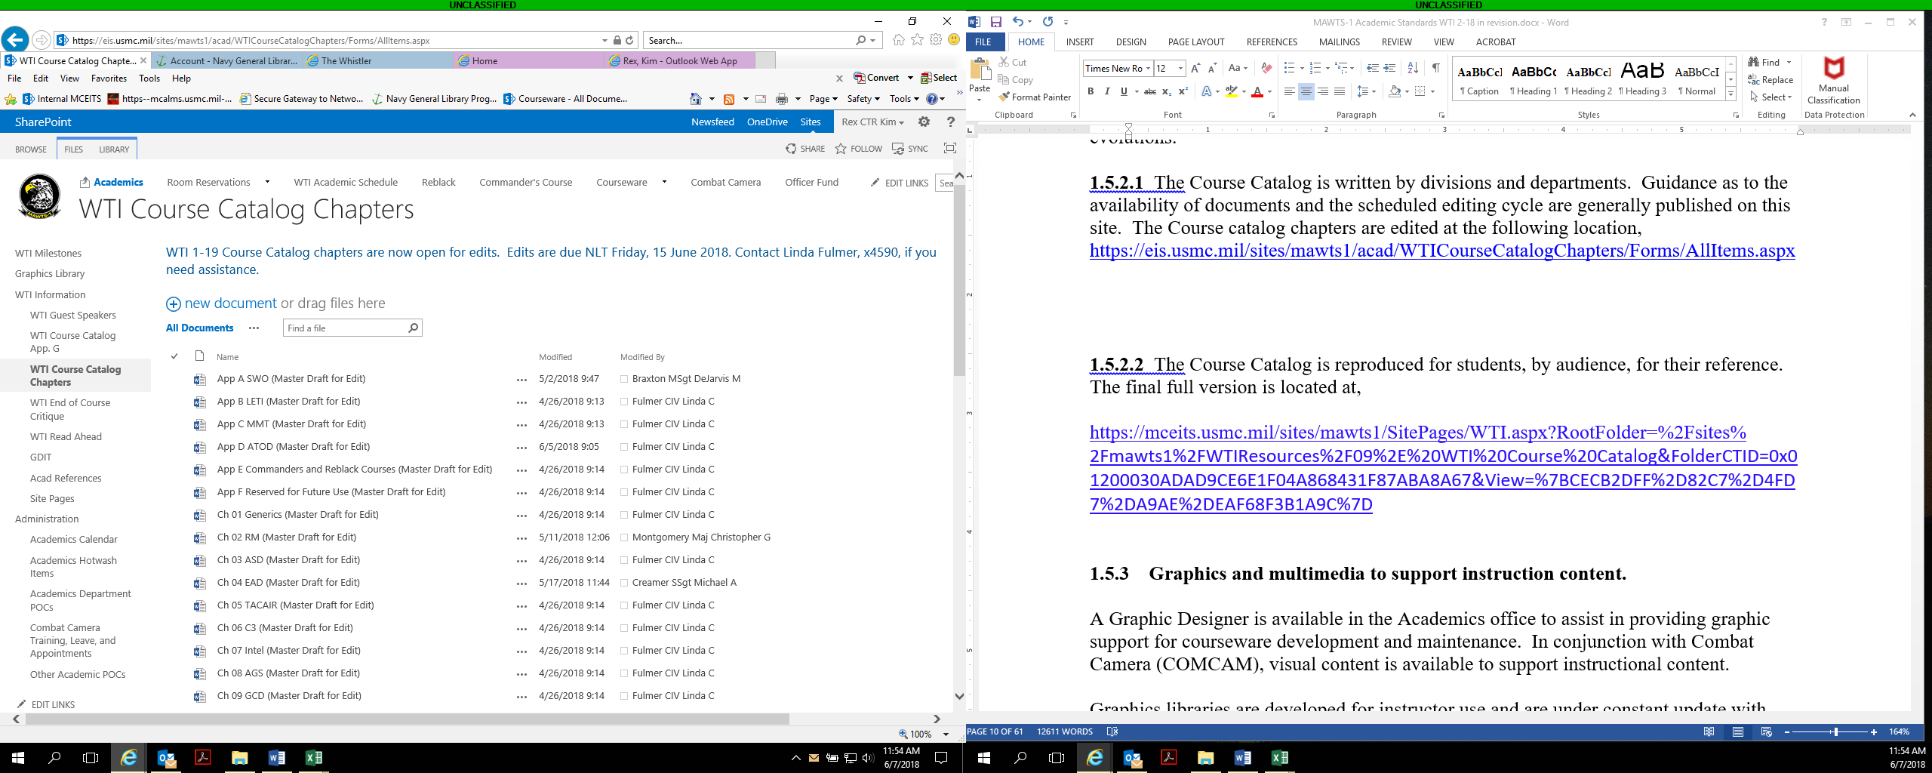

**1.5.2.2** The Course Catalog is available for students, by audience, for their reference in a digital format and posted on the tablet network. The final full version is located at: https://mceits.usmc.mil/sites/mawts1/default.aspx and https://intelshare.intelink.sgov.gov/sites/mawts1

**1.5.3 Graphics and multimedia to support instruction content.**

A Graphic Designer is available in the Academics office to assist in providing graphic support for courseware development and maintenance. In conjunction with Communication Strategy and Operations (COMMSTRAT), formerly Combat Camera and Public Affairs, visual content is available to support instructional content.

Graphics libraries are developed for instructor use and are under constant update with recent assets. These graphics are available at the following locations:

NIPR: https://eis.usmc.mil/sites/mawts1/acad/Lists/GraphicsLinks/AllItems.aspx

SIPR: X:\Academics\15. Instructor Media\Clipart

To access the proper graphics, select both the thumbnail then the preview image. This is important for images with a transparent background. Right clicking and saving a thumbnail or preview image will allow transparencies to be filled. Once the proper image has been opened and is the only thing in the browser window, right click and select “Save picture as” to the desired location.

DoD and Marine Corps imagery sites:

* DoD official imagery archival site at www.defenseimagery.mil/index.html
* Marine Corps imagery archival site at http://www.marines.mil/Photos.aspx
* Defense Visual Information Distribution Service archival site at https://www.dvidshub.net/

Additional imagery is also housed in-house on a closed network, internal server.

Additional support from the COMMSTRAT, formerly COMCAM, is referenced on the MCEITS page located at https://eis.usmc.mil/sites/mawts1/acad/Pages/COMMSTRAT.aspx

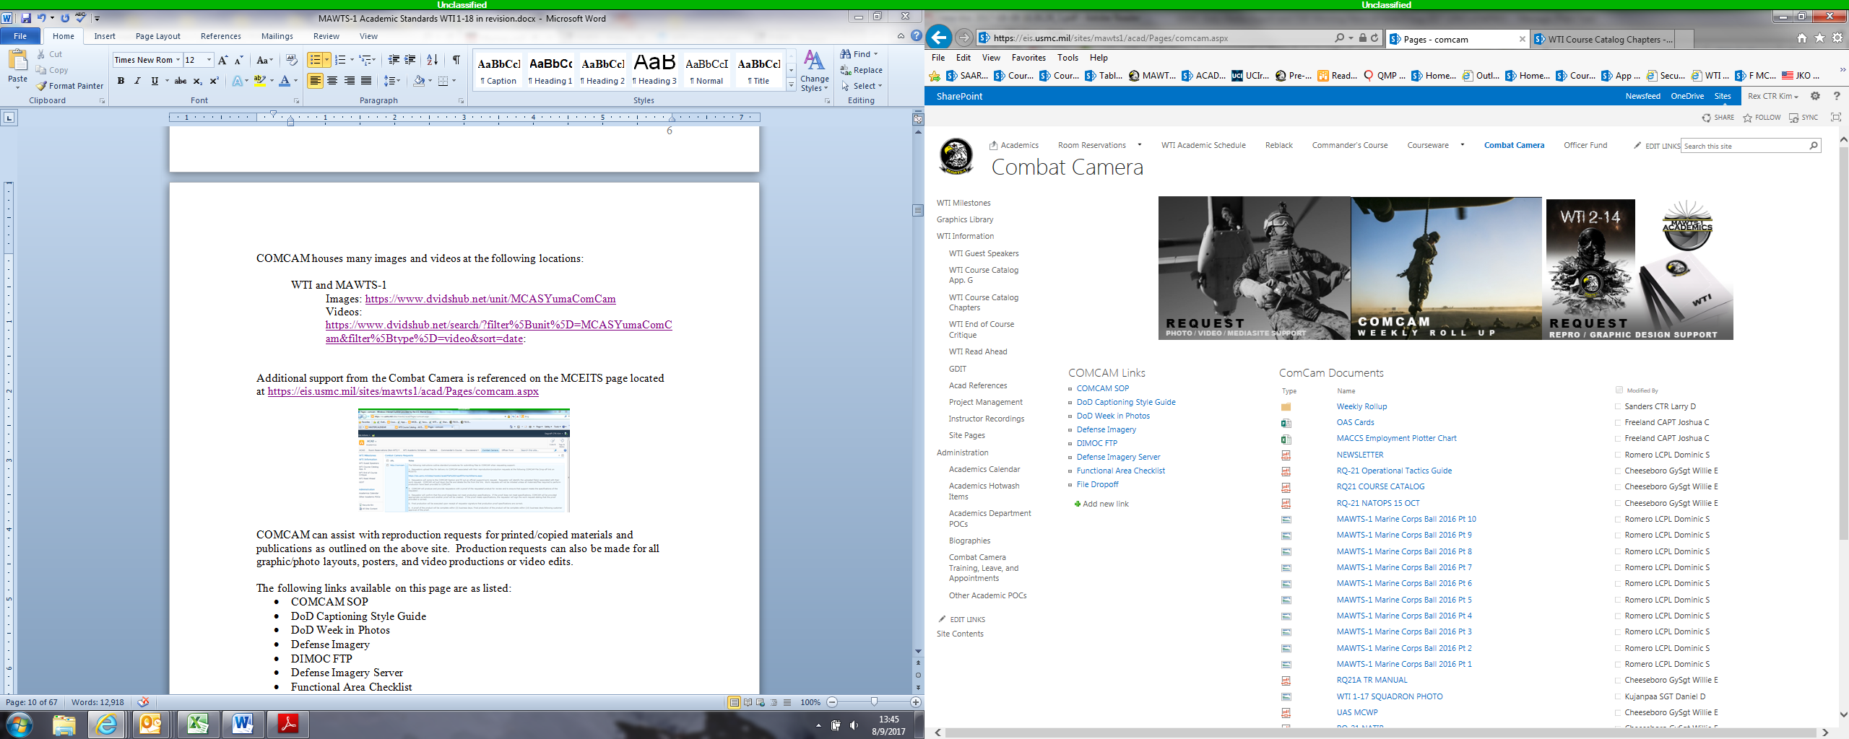

COMMSTRAT can assist with reproduction requests for printed/copied materials and publications as outlined on the above site. Production requests can also be made for all graphic/photo layouts, posters, and video productions or video edits. **Please be aware** that all photo and video requests are to be validated in person to ensure that all details of the request are present.

The following links available on this page are as listed:

* COMMSTRAT
* DoD Captioning Style Guide
* DoD Week in Photos
* Defense Imagery
* DIMOC FTP
* Defense Imagery Server
* Functional Area Checklist
* File Dropoff

**1.6. WTI Read Ahead Materials.** Read-ahead materials enable Prospective WTI (PWTI) students to have a solid understanding and baseline knowledge of doctrinal aviation prior to attending the course. The WTI course of instruction is built upon this knowledge. Thus, it is imperative for the PWTI to become familiar with doctrine contained in the read ahead to gain the maximum benefit from the course. An Inventory exam, described below, will be administered the first day of WTI to ensure adequate mastery. Proper preparation will lead to a solid performance during the WTI course.

The current Read Ahead material is in the form of an Interactive Courseware (ICW) program hosted on the Marine Corps Aviation Learning Management System (MCALMS) at https://mcalms.usmc.mil/default.aspx?1=1. Students are directed in a letter distributed by ACAD to search for **MAWTS1** in the “Online Course Catalog” under “General Training” to locate the course titled “MAWTS-1 Prospective Weapons and Tactics Instructor ICW” and complete the training.

The ICW consists of a courseware introduction and ten interactive modules:

* Weapons and Tactics Training Program (WTTP)
* Air Reconnaissance (AR)
* Antiair Warfare (AAW)
* Assault Support
* Control of Aircraft and Missiles
* Electronic Warfare (EW)
* Offensive Air Support (OAS)
* Aviation Ground Support (AGS)
* Coordination Measures
* Spectrum Warfare

It is estimated that the Read Ahead requires 11 hours for adequate completion. Throughout the ICW, “Comprehension Checks” allow students to check for mastery. The course concludes with a comprehensive assessment, entitled the “Practice Test,” that consists of 50 scored questions. It is estimated that it will take students an additional 60 minutes for completion of the end-of-course practice exam.

The Inventory Examination is based on the read ahead material. It will be administered on the morning of the first day of WTI. The exam consists of 50 complex, multiple choice and true/false questions. The Inventory Exam test questions are generated from the Read Ahead content. The exam is maintained and housed by the MAWTS-1 Academics office in Question Mark Perception (QMP). The Valiant Training Systems Management (TSM) Instructional Systems Developers (ISDs), under the direction of the Academics Assessment Officer, validate, randomize, and generate the exam prior to each WTI.

The following link is where the offline version of the read ahead can be found, along with a PDF of the course: https://mceits.usmc.mil/sites/mawts1/SitePages/WTI.aspx?RootFolder=%2Fsites%

2Fmawts1%2FWTIResources%2F10%2E%20WTI%20Read%20Ahead&FolderCTID=0x01200030ADAD9CE6E1F04A868431F87ABA8A67&View=%7B7F303023%2D6195%2D47DD%2D8E6B%2D0C6BE4B6D34C%7D

**1.6.1 Distribution**. The Academic Department will distribute the read ahead material in digital format upon request from a department or division representative. It is the responsibility of the departments to distribute the read ahead information to the PWTIs. Foreign attendees do not receive the Read Ahead. Therefore, they are not tested on the content. .

**1.7. Courseware.** MAWTS-1 will remain the model for excellence in instruction for USMC aviation. It requires significant effort to develop, produce, maintain, and deliver academic instruction. The following section will outline the standards by which all courseware will be constructed, formatted, practiced, approved, presented, and tested.

**1.7.1 Courseware Revision and Maintenance Timelines.** To ensure currency and accuracy, it is not uncommon for courseware to undergo dramatic change in the scope of a few months. Revisions to existing courseware must be made and provided to Academics prior to Third Freeze. The MAWTS-1 academic milestones account for this and provide enough lead time for an instructor to modify and update their courseware prior to each WTI course. Milestones must be met to include Murderboard completion, courseware revision, and standardization prior to WTI.

**1.7.2. Storage.** MAWTS-1 courseware is housed in a folder structure on respective repositories.  The folder structure allows for the storage of all presentations, their associated media, and other academic support items used for MAWTS-1 and Fleet distribution, on the NIPR and SIPR Internet sites.  The Intranet houses another repository for the storage of “Course Revision” documents. These documents are used as a communication tool between the instructor and the standardization team. It outlines changes made to the courseware, items for consideration, questions/concerns regarding the courseware (including inequities in classification in classified briefs), and questions or comments regarding assessment items for that course that currently reside in Question Mark Perception (QMP), if applicable.

**1.7.3 Repository Locations**

**Unclassified Courseware - NIPR**

* Courseware Repository
  + All Unclassified courseware is housed and maintained in this repository. While this can be accessed outside of MAWTS-1, it is CAC enabled and is used by instructors and the fleet to locate and courseware for WTI and associated Academic Support Package (ASP) courses.
  + The folders are named with the title of the courses. In some instances, the title is preceded by sponsored department/division. (Direct link: https://mceits.usmc.mil/sites/mawts1/Courseware/Forms/AllItems.aspx
* Revision Documents
  + All courseware has a document on the “Courseware Revisions” site located at: https://eis.usmc.mil/sites/mawts1/acad/CWRevisions/Forms/AllItems.aspx
  + When courseware is being revised by the instructor or by the Academics team (general format, syntax, grammar, and items regarding standardization) revisions are recorded on the revision document. The purpose of this form is to be a communication tool between instructors and the Instructional Systems Development (ISD), team (Instructional Systems Developers [ISDs], Graphic Artist, Editor).

**Classified Courseware – SIPR**

* Intelink and Intelshare house the following MAWTS-1 instructional products (please note that there is an underscore between “mawts1/” and “layouts” in the below hyperlink):
  + **Courseware** is located at the following location: https://intelshare.intelink.sgov.gov/sites/mawts1/_layouts/15/start.aspx#/CoursewareRepository/Forms/AllItems.aspx
  + **Revision documents** are located at: https://intelshare.intelink.sgov.gov/sites/mawts1/_layouts/15/start.aspx#/CoursewareRevisions

The Valiant TSM team maintains a spreadsheet containing a listing of all the current courses for reference.

**1.7.4 Revising and Maintaining the Existing Courseware.** Ideally,courseware already existing on the repositories SHOULD be revised and maintained directly on the existin**g** repository, using the “Edit” mode when opening a presentation**.** This will ensure that the courseware will remain housed on the existing repository. Per Squadron Order 1550, it is mandatory that all MAWTS-1 courseware reside on the designated SharePoint libraries.

**1.7.5 Courseware Version Control Measures.** Instructors may independently load courses and media onto the repository(s) using the “Submission Folder.” located at https://eis.usmc.mil/sites/mawts1/acad/Courseware%20Submission/Forms/AllItems.aspx.

If media associated with the course is not housed in the folder structure, media files will be submitted using the same method.  The file limit is 50 MB on the both NIPR and SIPR.  A large file might be due to embedded videos or animations. Larger files will need to be uploaded with the assistance of the ACAD office.

The submission of classified courses will be done on SIPR Intranet following a similar process. Please contact an ISD or Kim Miller, Lead Instructional Systems Developer, Valiant, at kim.rex.ctr@usmc.mil on NIPR or kim.degraff@usmc.smil.mil on SIPR or 269-2685, with any questions or of any needed assistance.

**1.7.5.1 Courseware submission process**. Submitting new courseware on the NIPR can be completed independently using the following methods.

**1.7.5.1.2 Unclassified / NIPR Courseware Submissions – MCEITS**

Submitting new courseware to the NIPR can be completed by the following

methods.

**Submitting onto the Sharepoint:**

To create a folder within the library, click anywhere within the page and then “Files” in the top menu.

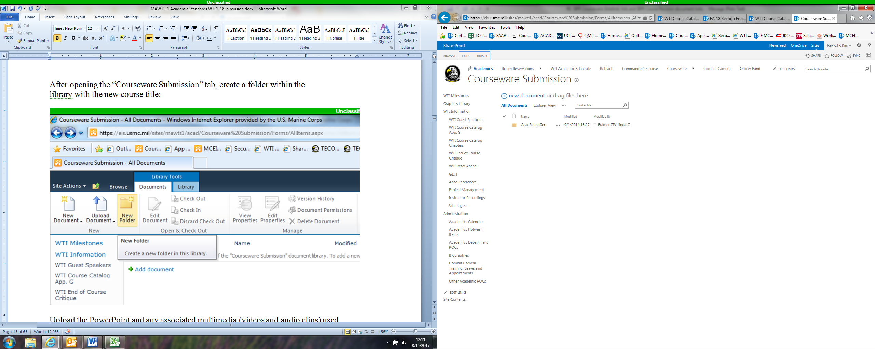

Select “New Folder” from the options and name the folder the course title.

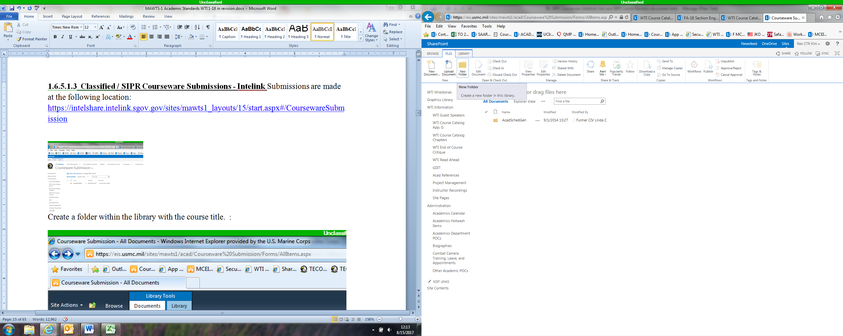

Submit the courseware, all associated media files, and the Course Revision document, if applicable.

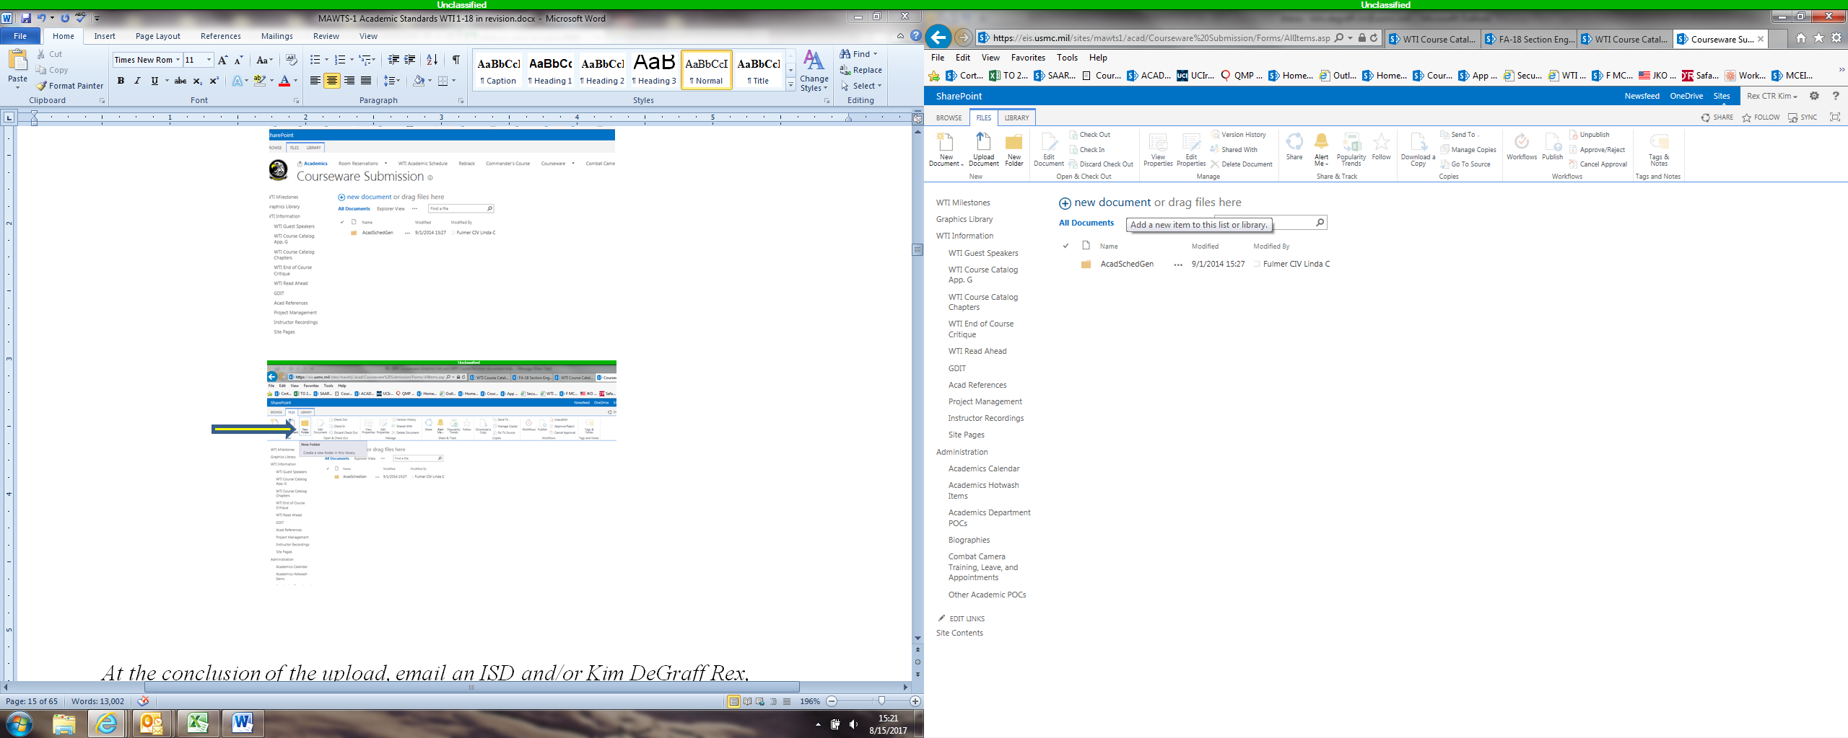

*At the conclusion of the upload, email an ISD and/or Kim Miller,* *kim.rex.ctr@usmc.mil**, to indicate the course and associated media needs transferring to the repository.*

**1.7.5.1.3 Classified / SIPR Courseware Submissions - Intelink** Submissions are made similarly at the following location: https://intelshare.intelink.sgov.gov/sites/mawts1_layouts/15/start.aspx#/CoursewareSubmission

Upload the PowerPoint and any associated multimedia (videos and audio clips) used during the presentation into the folder using the “Upload Document” item in the top menu bar or the “+Add document” item in the new folder.

**1.7.5.2 Creation of New Courseware.** The MAWTS-1 PowerPoint presentation template should be utilized for the creation of all courseware. This template can be found on both the NIPR MCEITS and SIPR SharePoint sites as listed above. It is the only item on the repository not housed in a folder.

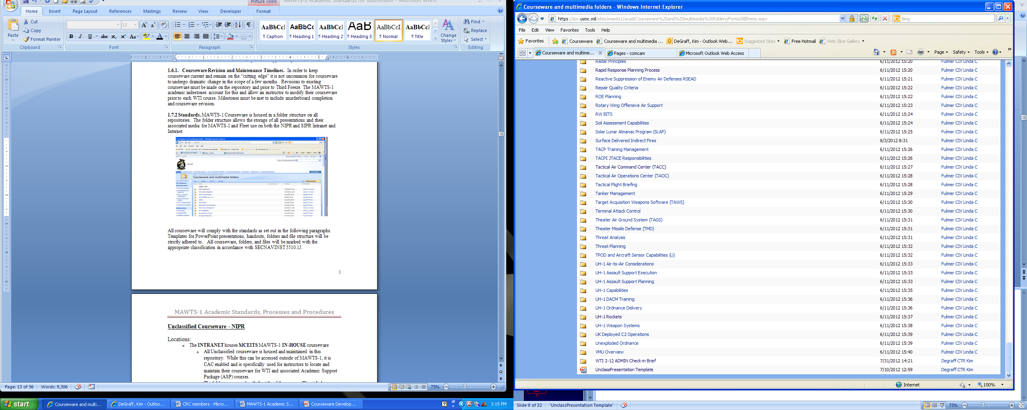

**1.7.6 Standardization**. All courseware will comply with the standards as set out in the following paragraphs. Templates for PowerPoint presentations, handouts, folders and file structure will be strictly adhered to. All courseware, folders, and files will be marked with the appropriate classification in accordance with *DoDM 5200.01-V2*

Material that is deemed inappropriate or not in keeping with the professional standards of a MAWTS-1 presentation will be disallowed during the Murderboard process.  Clarification on the appropriateness of material can be forwarded to the Academic Department Head prior to Curriculum Review Committee (CRC) review.

Courseware Standards are located on the MCEITS site at https://eis.usmc.mil/sites/mawts1/acad/acadsop/Courseware%20Standards%20Quick%20Reference.aspx

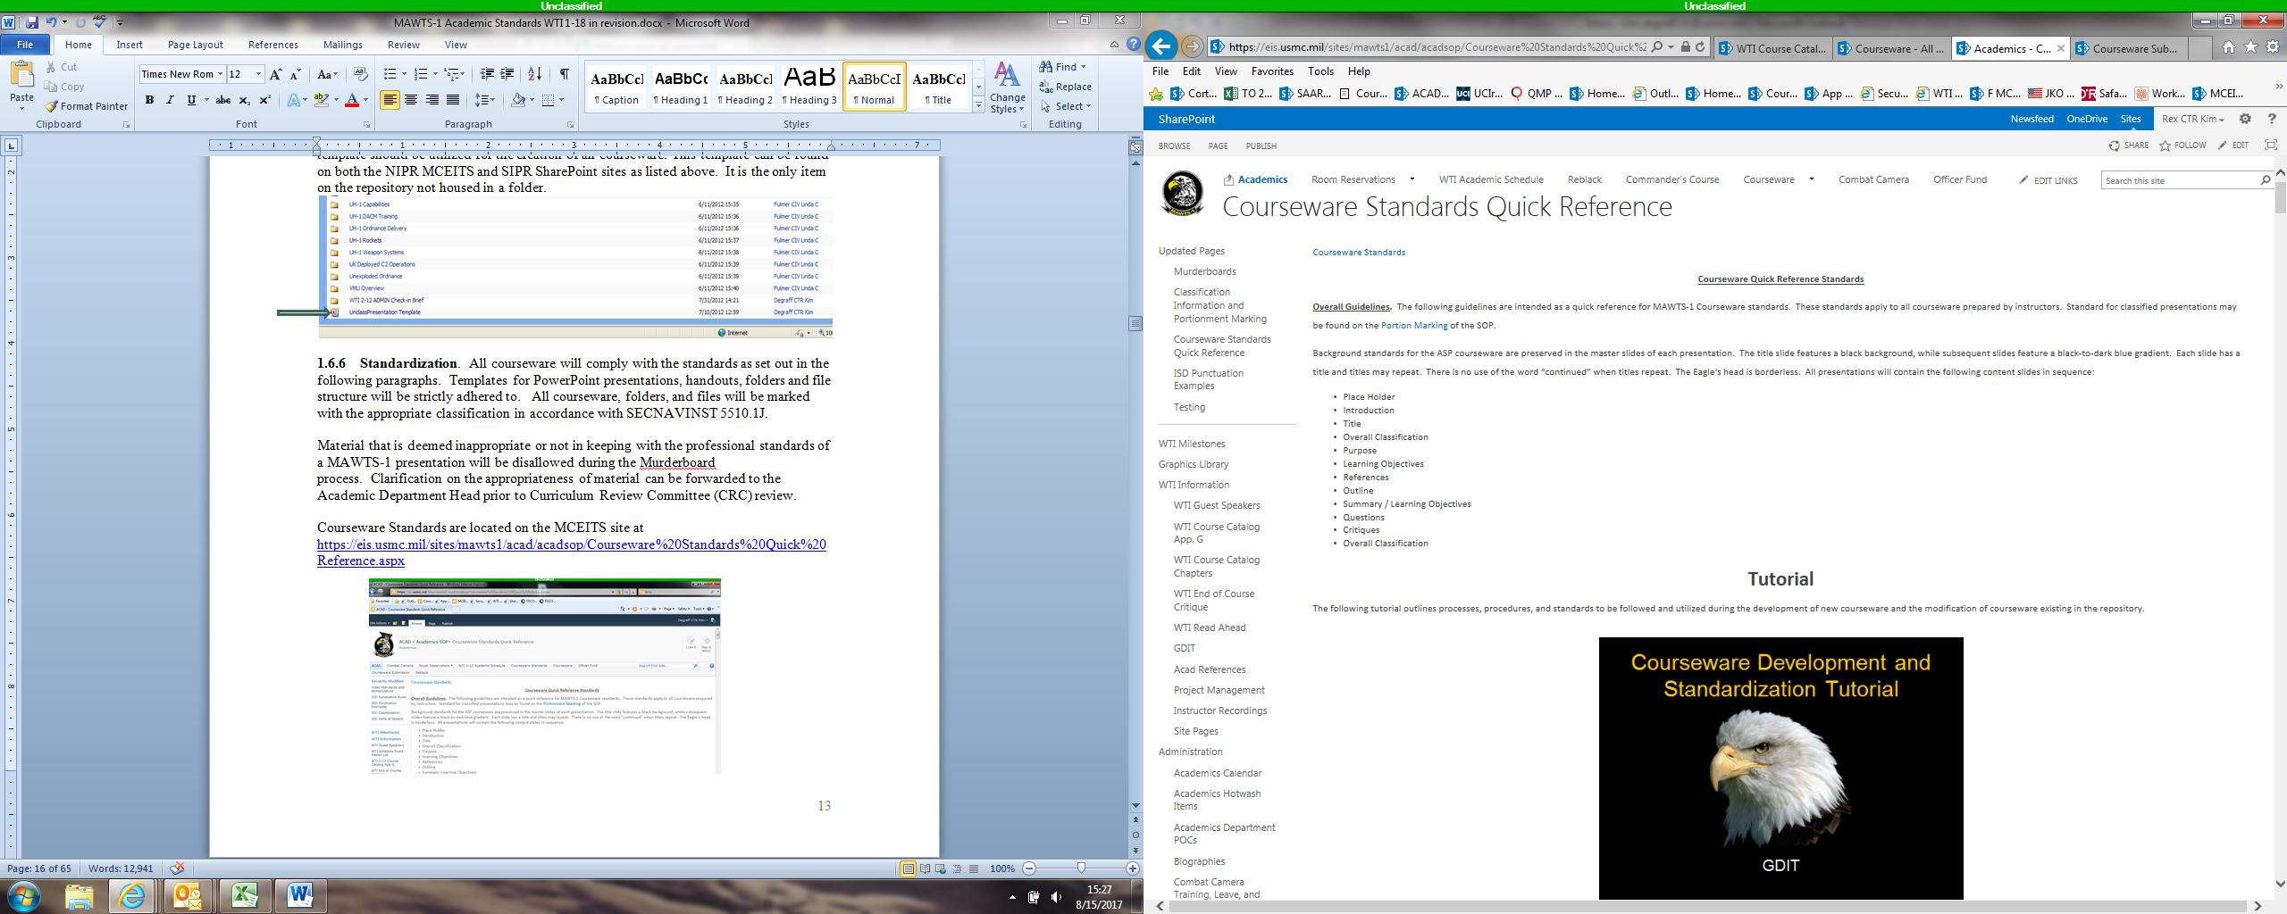

For reference, a tutorial outlining the processes, procedures, and standards are also included at this site.

**1.7.6.1 Courseware Design.**

**1.7.6.1.2 Generics Courseware Design** implications:

Generally, avoid the assumption that all students from all divisions and departments will be familiar with all acronyms and their definitions. Therefore:

* Acronyms used within each lesson should be defined at first-time use *in text*, not in titles, according to their definitions in a standardized glossary.  Respective divisions may have variations in acronym definitions.
* Acronyms that may be used in the title of a lesson will need to be defined at first-time use within the lesson proper.
* Acronyms that may be used first-time in a graphic, where mechanical or visual restrictions must be considered, must be defined in text when discussed, or in a footnote, or in some other fashion.
* Acronyms that may be used only a few times in a lesson should be avoided.

Exceptions:

Instructor and/or squadron preference may be recognized. Therefore, exceptions to the general guidance above should be noted in the simplest language when the lesson is submitted for approval.

**1.7.6.1.3 Common or Specific Courseware Design** implications:

Generally, an assumption *may* be made that students from a respective department or division will be familiar with most, if not all, the acronyms common to their departments/divisions. As such, an instructor and/or division has greater leeway in determining whether to define an acronym at first-time use or refer to the acronym as prerequisite knowledge. It would be advised that all acronym definitions be placed in a glossary for reference.  Respective divisions may have variations in acronym definitions.

* Acronyms that may be used in the title of a lesson will need to be defined at first-time use within the lesson proper.
* Acronyms that may be used first-time in a graphic, where mechanical or visual restrictions must be considered, must be defined in text when discussed, or in a footnote, or in some other fashion.

Exceptions:

Instructor and/or division preference may be recognized. Therefore, exceptions to the general guidance above should be noted in the simplest language when the lesson is submitted for approval.

**1.7.6.2 Overall Guidelines-Format.** The following guidelines are intended as a quick reference for MAWTS-1 Courseware standards for formatting.

A similar document, constructed in PowerPoint and referred to as a “Tutorial” can be found at the following site: https://eis.usmc.mil/sites/mawts1/acad/acadsop/Courseware%20Standards%20Quick%20Reference.aspx.

These standards apply to all courseware prepared by instructors.  Standards for classified presentations may also be found on the Portion Marking link on the “Courseware Standards” page referenced above, as well as in this “Classification Information” portion of this document.

Background standards for the ASP courseware are preserved in the master slides of each presentation.  The title slide features a black background, while subsequent slides feature a black-to-dark blue gradient.  Each slide has a title and titles may repeat.  There is no use of the word “continued” when titles repeat.  The Eagle's head is borderless.  Slides will not be numbered.  All presentations will contain the following content slides:

* Disclosure slide
* Overall Classification
* Title
* Introduction
* Purpose
* Learning Objectives (See “Development of Learning Objectives” guidance that follows – section 1.6.6.4)
* References
* Outline
* Summary / Learning Objectives
* Overall Classification
* Questions / Critique

**1.7.6.2.1 Unclassified Courseware Design**

**Disclosure Slide.** All presentations will begin with a Disclosure slide that includes a disclosure statement required by the Foreign Disclosure Office (FDO).  This slide is displayed prior to the class beginning.  No text or other graphics other than those depicted below will be utilized.

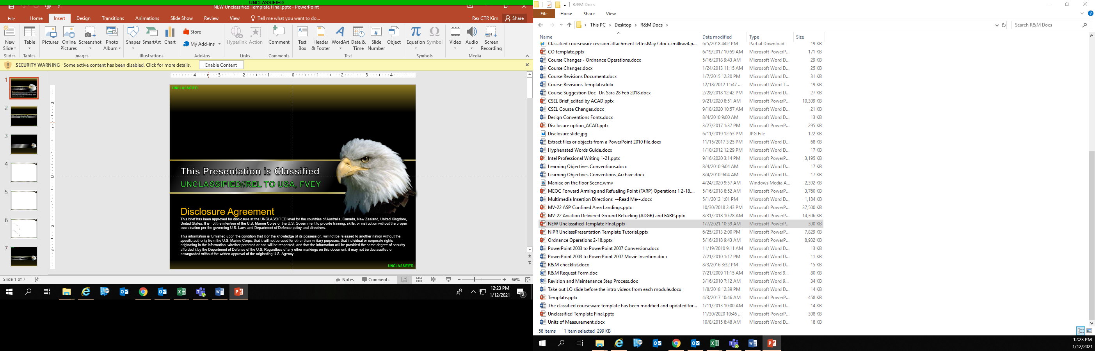

**Introduction.** All presentations will contain an introduction.  Instructors have discretion in what content their introduction will contain, however, suggestions are as follows:

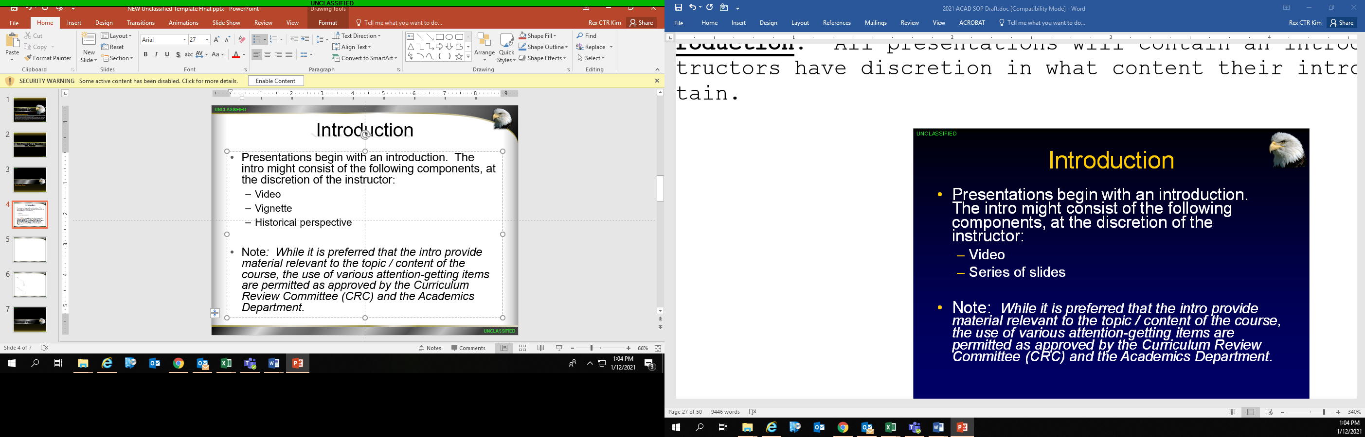

**Title Slide.**  The Title Slide shall be the first slide following the class introduction, if present.  Course titles utilize the standard capitalization of the first letter in each word. No callsigns will be used on the title slide.

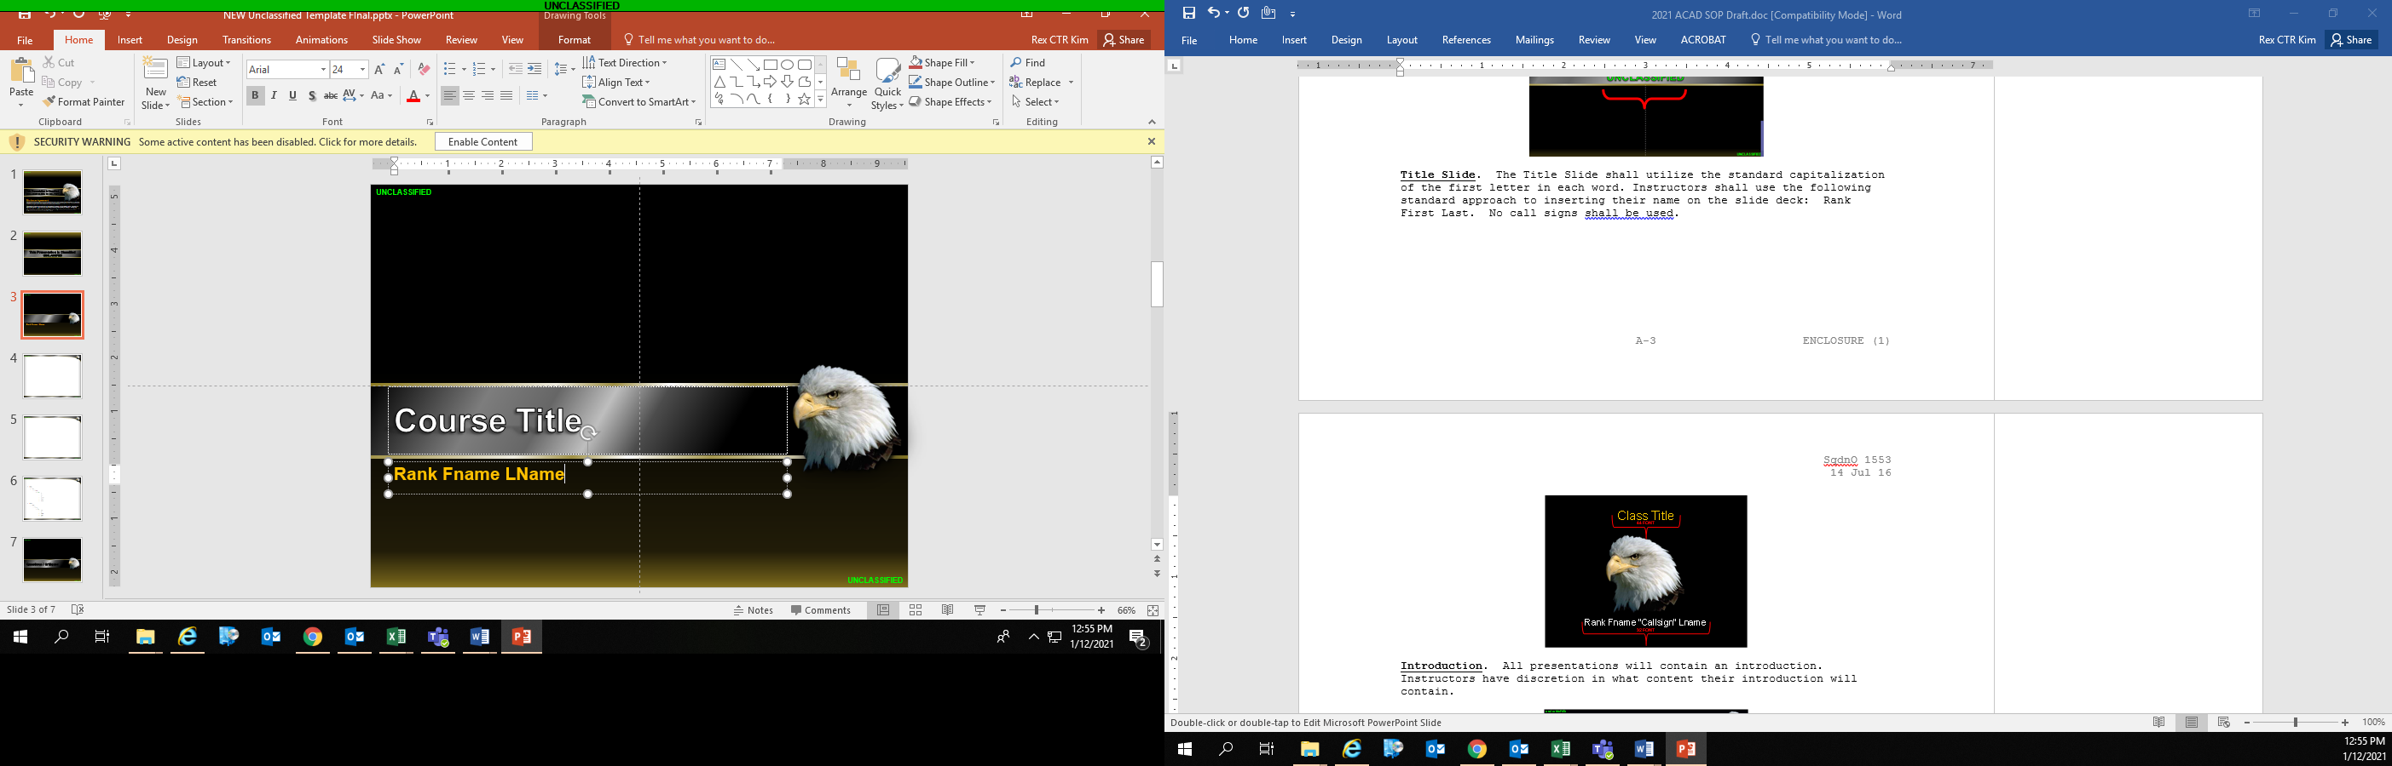

**Classification Slide.** This slide provides the overall classification of the presentation.  The highest level of information contained in the presentation should be annotated.  Classification markings are in the upper left and lower right corners of the slide.  This slide will follow the title slide at the beginning of the presentation and will be the concluding slide at the end of the presentation, except for Generics and Super Commons courses, as they require the Questions/Critique slide as the concluding slide. It serves as a visual reminder for students to complete their critiques.

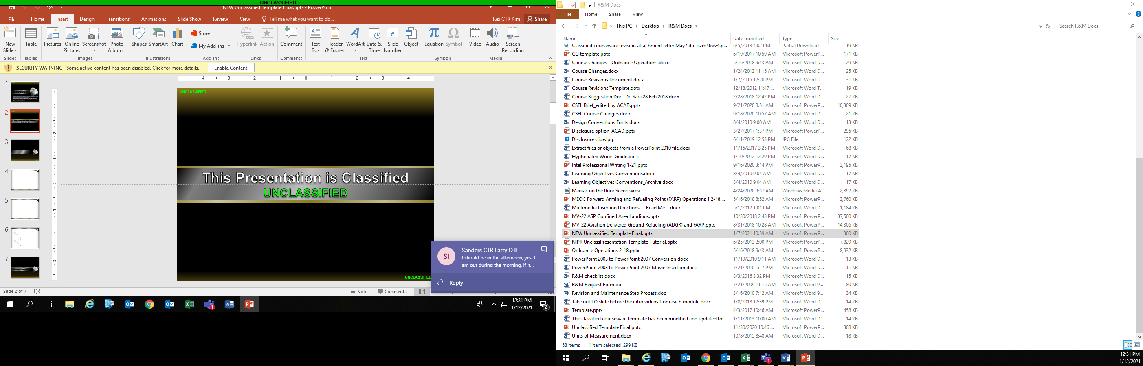

**Purpose slide.** Purpose slides should contain complete sentences. This complete sentence may be broken into bullets if the slide will better present the precise material points to be brought out.  All complete sentences will end in a period.

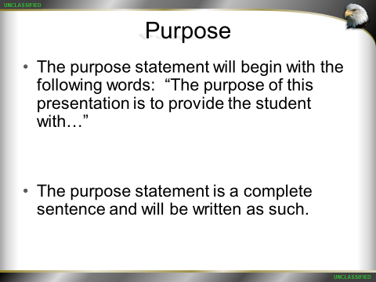

**Learning Objectives****. For Learning Objective Development refer to “Learning Objective Development” and “Appendix G: Bloom’s Taxonomy Verbs” handouts**

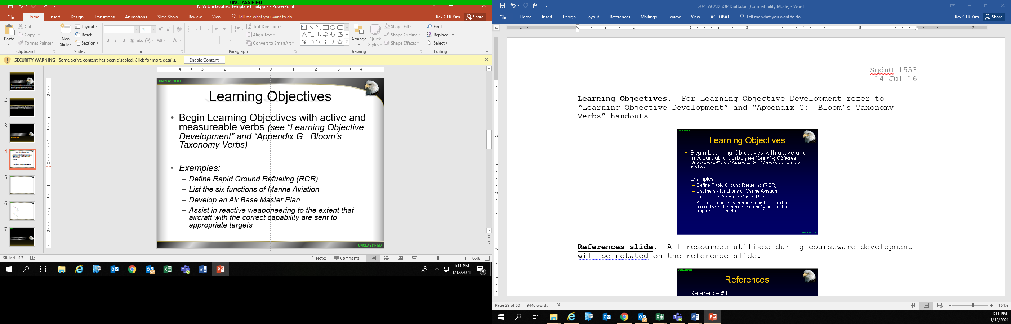

**References slide. All resources utilized during courseware development will be notated on the reference slide.**

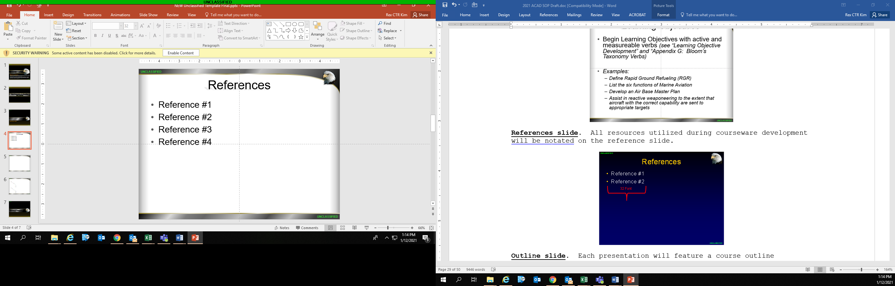

**Outline slide.** Each presentation will feature a course outline immediately following the “References” slide. This outline should include each of the discussion topics included within the presentation.  This slide should be repeated as a transition slide for each topical change in the presentation.  The topic under discussion should appear white, while all the other topics (both proceeding and subsequent to the current topic) should be shown in gray (White, Background 1, 50% darker) .  See the example of an outline slide below:

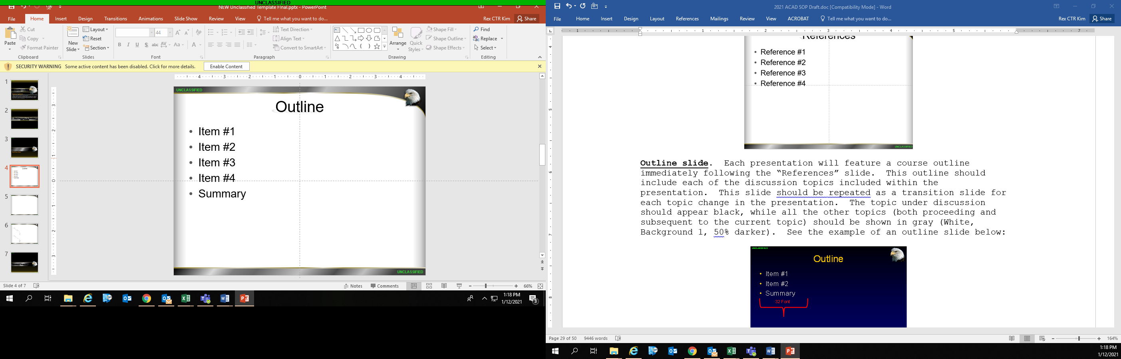

**Body Slides.** The majority of the presentation should be in accordance with the following image.  Slide titles utilize the standard capitalization of the first letter in each word.  Titles that encroach upon the EAGLE should be carriage returned to form a second line.  Two line titles should be 40 pitch. Three or more line titles are prohibited.

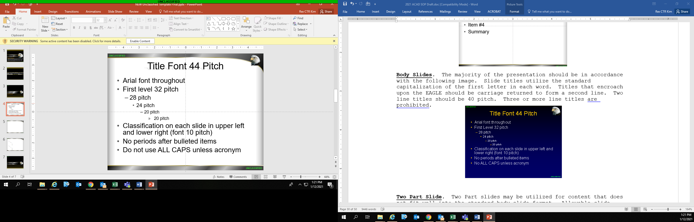

Font

**Font Colors**

**Text will be black, unless highlighting of selected content is desired. See the font color below for guidance regarding selecting highlighting colors. Red should be avoided, as the color is associated with classified content. Yellow and/or gold fades into the white background on white body slides.**

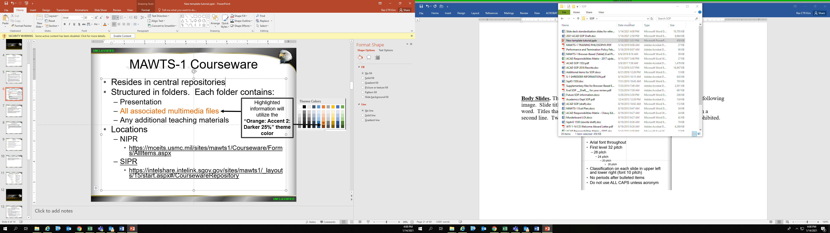

**Two Part Slide.** Two Part slides may be utilized for content that does not fit well into the standard body slide format.  Allowable slide fonts are to be in accordance with the below sample.

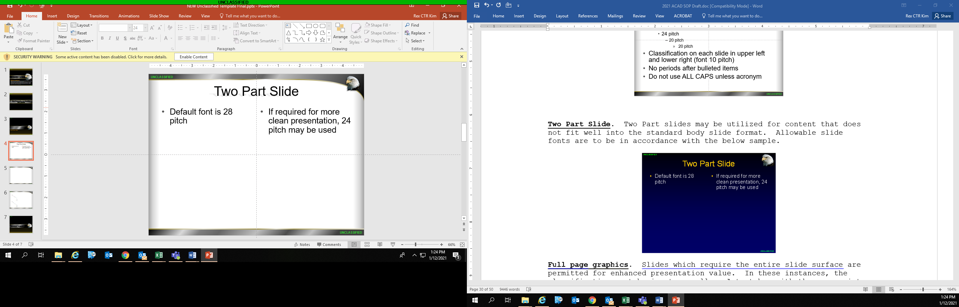

**Full page graphics.** Slides which require the entire slide surface are permitted for enhanced presentation value.  In these instances, the classification must be input manually.  A text box with the appropriate classification should be placed in the upper left and lower right corners in accordance with standard classification marking procedures.  The background of the text box should be solid black.

UNCLASSIFIED

UNCLASSIFIED

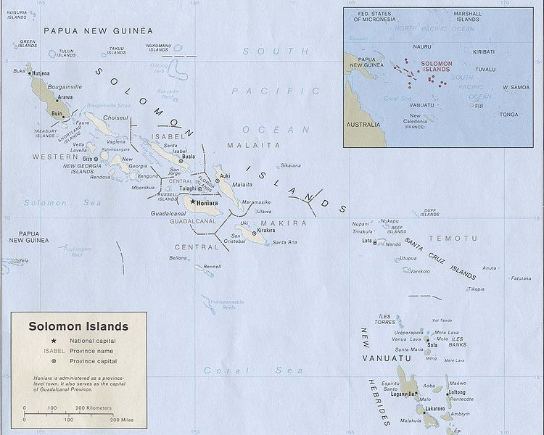

Full Graphic Slide

10 Font ALL CAPS

Black Fill

Full Graphic Slide

10 Font ALL CAPS

Black Fill

**Summary.**  All presentations will contain a summary.  The last bullet of the outline slide should be "Summary".  The slide immediately following the "Summary" outline slide can be the Learning Objective slide(s) to review with students.

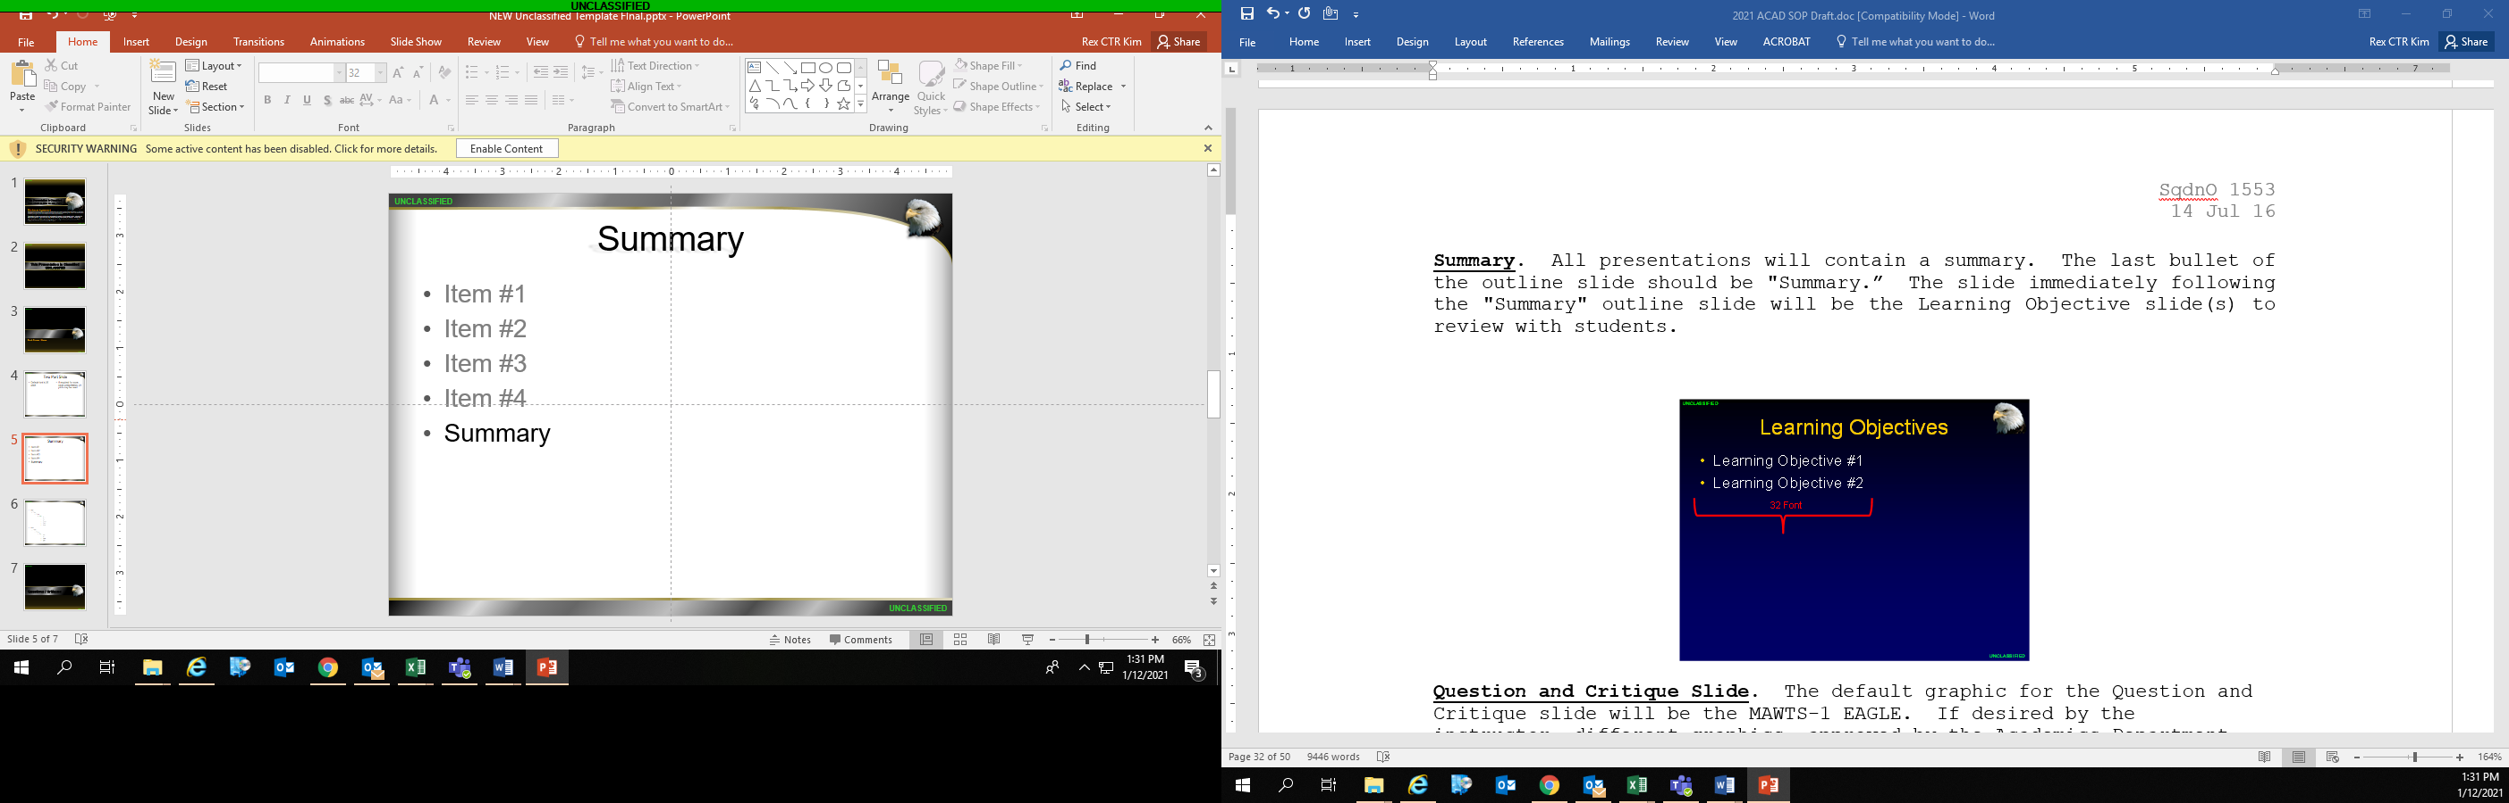

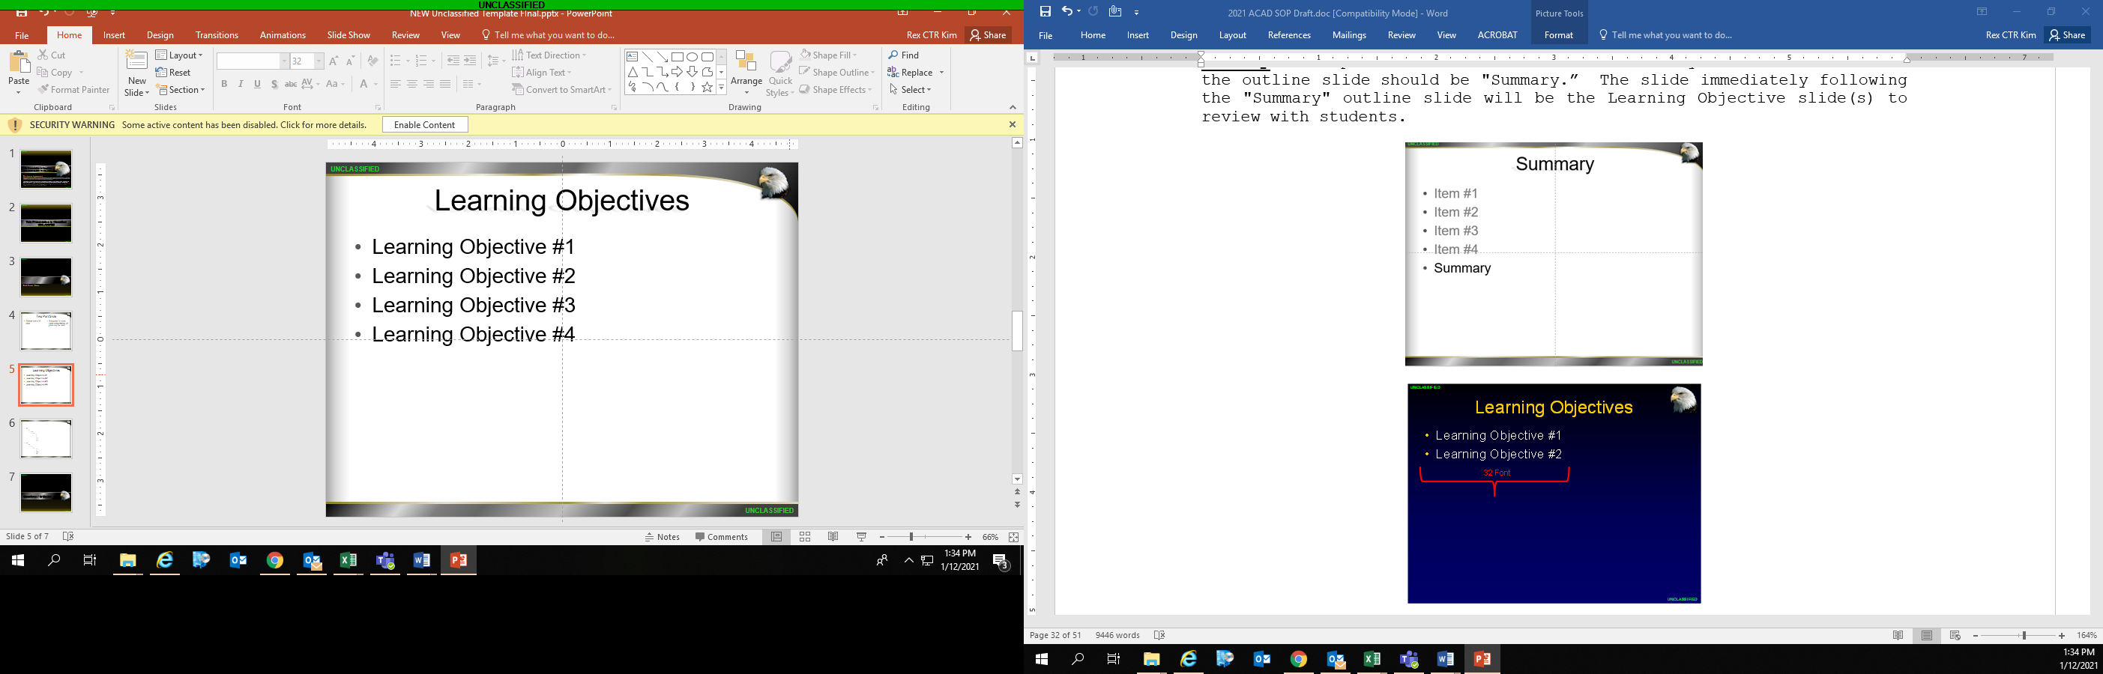

**Classification slide.** The slide before the Question / Critique slide of Generics / Super Commons presentations will be the 'Overall Classification" slide.  It will be the concluding slide on all other presentations. The purpose of this slide is to reinforce the sensitivity of the information which has just been presented.



**Questions / Critique Slide.**  The final slide of the presentation on a Generics / Super Commons courses is the Question / Critique slide. It will precede the classification slide on all other courses. The default graphic for the Question and Critique combined slide will be the MAWTS-1 EAGLE.  If desired by the instructor, different graphics, approved by the Academics Department, may be used as substitutes.  Background will remain black.

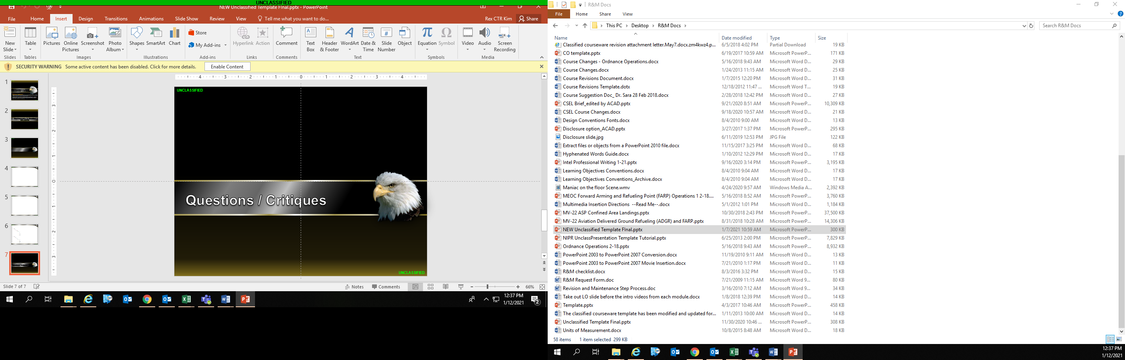

**1.7.6.2.2. Classified Slide Design.** For the development of a new course, the “Classified Template,” existing in the repository, will be utilized. It is located at the end of the listing of the Courseware Folders (see Courseware location for the specific site). The classified template consists of six master templates, each for the following classifications:

*U (default)

*SECRET

*SECRET//REL TO USA, ACGU

*SECRET//REL TO USA, FVEY

*SECRET//NOFORN

*CONFIDENTIAL

All slides will be reset into their respective classified templates. ACAD will ensure that this has occurred for each of the slides.

UNCLASSIFIED

FOR TRAINING PURPOSES ONLY

**Classified Title Slide.** Classification markings as will be used for all classified presentations.



**Classification Slide.** All classification slides will reflect the overall highest classification of the presentation.  It will have "UNCLASSIFIED" apportionment markings in the upper left and lower right corners of the classification slide.  All presentations which are RELEASABLE will be apportion marked per the below graphic.  Even if the USA is included in group classifications (i.e. ACGU, in reference to the U.S.), 'USA' will begin the releasability apportionment of the marking.

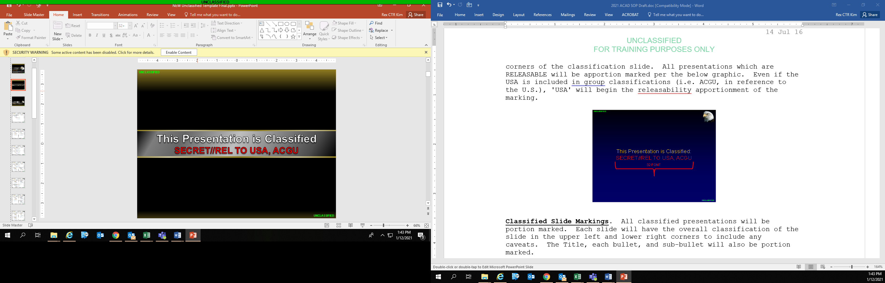

**Classified Slide Markings.** All classified presentations will be portion marked.  Each slide will have the overall classification of the slide in the upper left and lower right corners to include any caveats.  The Title, each bullet,and sub-bullet will also be portion marked.

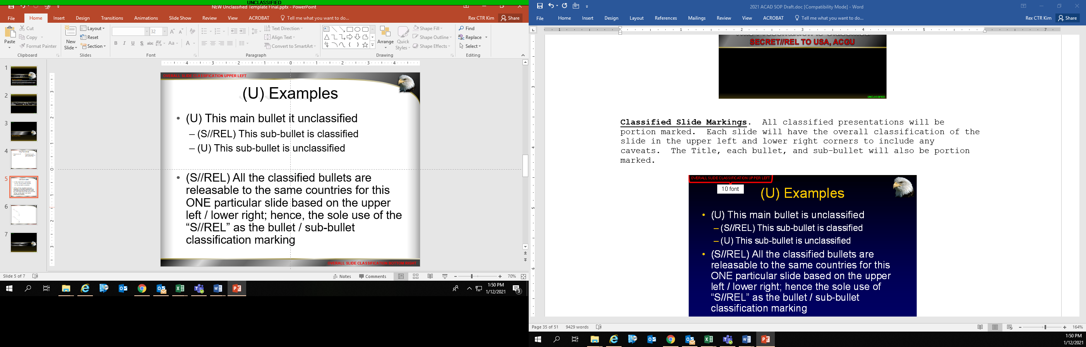

**Classified Slide Photo Markings.** Classified slides with photos shall be marked as indicated in the graphic below.  All photos on classified slides shall be marked.  Classifications shall be per classification font standards (5 font Arial) and placed in a black filled box within the photo.  The classification box may be attached to either the top of bottom of the photo, although the preference is for classifications to be placed in the bottom-right corner of the photo.  Photos taken from other sources that already contain classification markings do not require additional markings.

UNCLASSIFIED

FOR TRAINING PURPOSES ONLY

UNCLASSIFIED

FOR TRAINING PURPOSES ONLY

** Slides with an overall marking of UNCLASSIFIED do not require any other markings, to include photos.

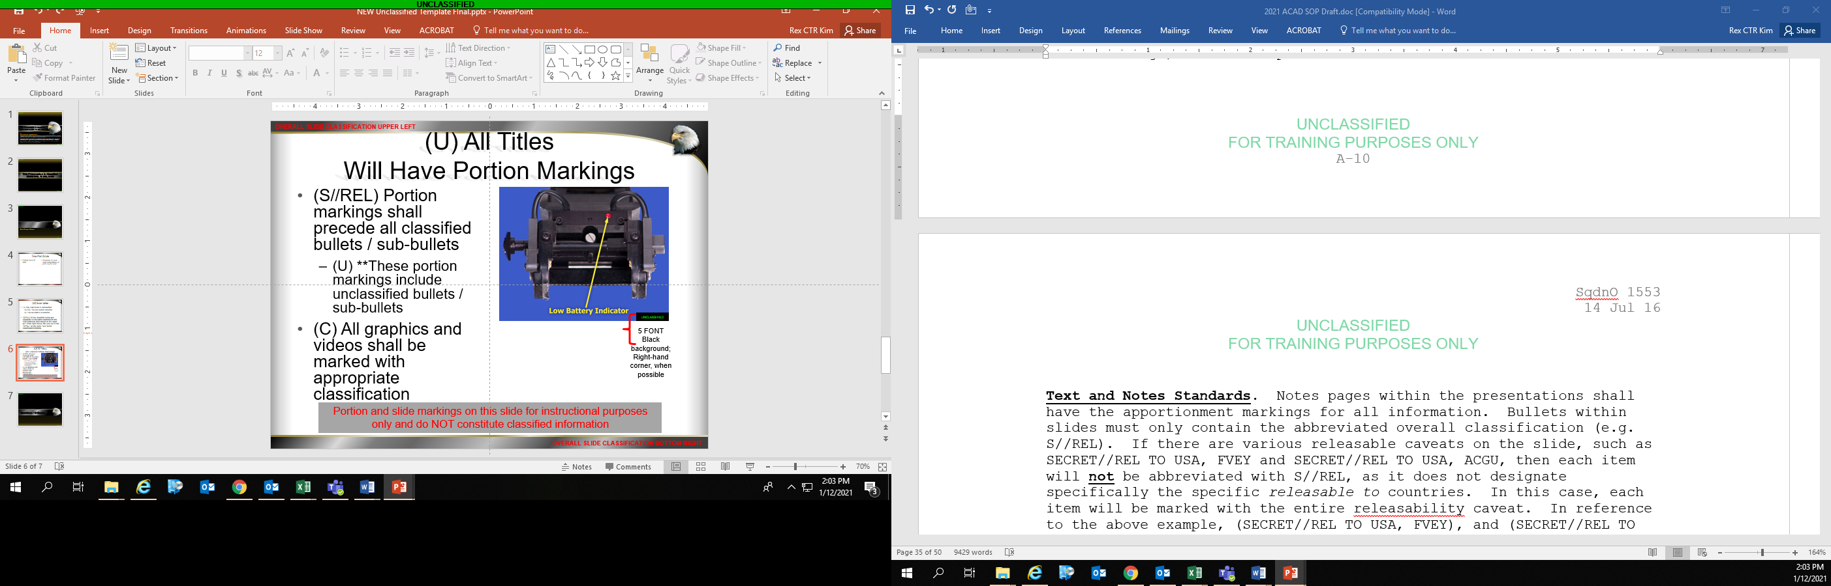

**Text and Notes Standards.**Notes pages within the presentations shall have the apportionment markings for all information.  Bullets within slides must only contain the abbreviated overall classification (e.g. S//REL). If there are various releasable caveats on the slide, such as SECRET//REL TO USA, FVEY and SECRET//REL TO USA, ACGU, then each item will **not** be abbreviated with S//REL, as it does not designate specifically the specific *releasable to* countries. In this case, each item will be marked with the entire releasability caveat. In reference to the above example, (SECRET//REL TO USA, FVEY), and (SECRET//REL TO USA, ACGU) before the appropriate text.

Within classified briefs only, UNCLASSIFIED bullets shall be notated as well by an apportionment marking (i.e. (U)).

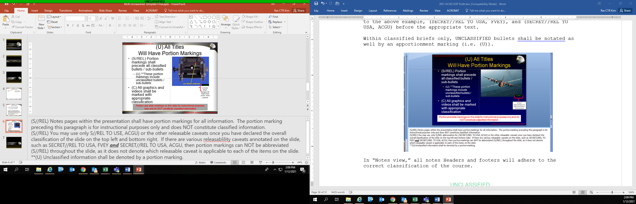

UNCLASSIFIED

FOR TRAINING PURPOSES ONLY

In “Notes view,” all notes headers and footers will adhere to the correct classification of the course.

**Question / Critique Slide OR Classification Slide**

Information on either of the slides (the Question / Critique slide for all Generics / Super Commons courses, and on the Classification Slide on all other courses) will include the source from which the information was derived as well as the declassification date.  (Derived from) shall be 'Multiple Sources' and (Declassify on) shall be one of the following:

*25 yrs (e.g. Standard military DTG 20351122) for Top Secret Information

*10 yrs for Secret information

*5 yrs for Confidential information.

This date is the creation date of the presentation or, if the creation date of the presentation is not available, the date the courseware was submitted to Academics.

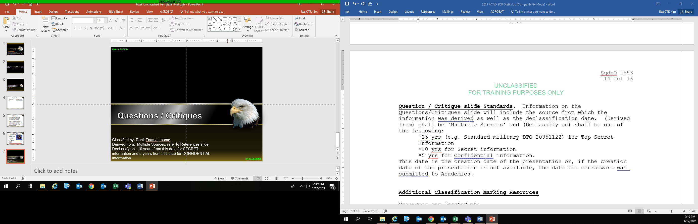

**1.7.6.2.3. Additional Classification Marking Resources**

**Classification basics** There are only three levels of classification.  Anything other than the below mentioned levels are known as 'caveats' or 'released markings'.  Caveats apply to all classification levels (i.e. TOP SECRET, SECRET, CONFIDENTIAL).

**TOP SECRET**

Disclosure will cause "extremely grave damage" to the United States

**SECRET**

Disclosure will cause "grave damage" to the United States

**CONFIDENTIAL**

Disclosure will cause "damage" to the United States

**UNCLASSIFIED** is not a classification level.  This marking is utilized to annotate that the material contained in the specific document or brief has no access restrictions.  The one caveat to this rule is the use of FOR OFFICIAL USE ONLY (FOUO).  FOUO may only be used with UNCLASSIFIED information and should be annotated as (U//FOUO) within any documents or briefs. Courses with the “Unclassified” and “Unclassified//FOUO” classification are generally housed on the NIPR network.

UNCLASSIFIED

FOR TRAINING PURPOSES ONLY

Overall classification of all documents and briefs will be of the highest classification of the information contained within that document or brief.

When multiple classifications and caveats exist in a presentation, the highest level of classification must be used as the overall classification of the document, slide or brief.

EXAMPLE: If a brief contains (SECRET//NOFORN) information as well as (SECRET//REL TO USA, FVEY), the overall classification of the document will be (SECRET//NOFORN). Refer to the “Tearline/Sanitation Hierarchy” visual on the following page as a quick reference regarding the levels of classification.

**SECRET CAVEATS:**

**SECRET//NOFORN**

The marking of NOFORN is only used for U.S. intelligence information.  A document or brief marked as (SECRET//NOFORN) contains U.S. intelligence information.  This information is generally gathered by U.S. Intelligence sources that is not to be released to foreign countries.

**SECRET**

If there is no intelligence information contained, and the information is not releasable, the item should be marked as SECRET.  SECRET information is generally information about friendly force capabilities that is not authorized for

release to foreign countries.  Only the originating authority may authorize the release of this information.

**SECRET//REL**

Information intended for release to foreign countries will possess the banner marking of (REL TO USA).  (REL TO USA) means that the originator has approved the document or brief, or apportionment thereof, to be released to specific foreign countries.  The (REL TO USA) line can list the try-graph of the countries authorized for release in acronym form in alphabetical order (e.g. AUS, CAN, GBR, USA).   This marking is required for all classified documents and presentations containing releasable information.

Common releasable caveats are the following:

* + - SECRET//REL TO USA, FVEY - Releasable to the United States, Australia, Canada, Great Britain and New Zealand
    - SECRET//REL TO USA, ACGU - Releasable to the United States, Australia, Canada and Great Britain
    - SECRET//REL TO USA, ISAF - Releasable to the International Security Assistance Force member countries

UNCLASSIFIED

FOR TRAINING PURPOSES ONLY

* + - SECRET//REL TO USA, NATO - Releasable to the North Atlantic Treaty Organization member countries

**Classification Hierarchy**



Governing doctrine publication: “Marking Classified National Security Information” *as required by Executive Order 13526, Classified National Security Information, December 29, 2009, and 32 CFR Part 2001, ISOO Implementing Directive, effective June 25, 2010*

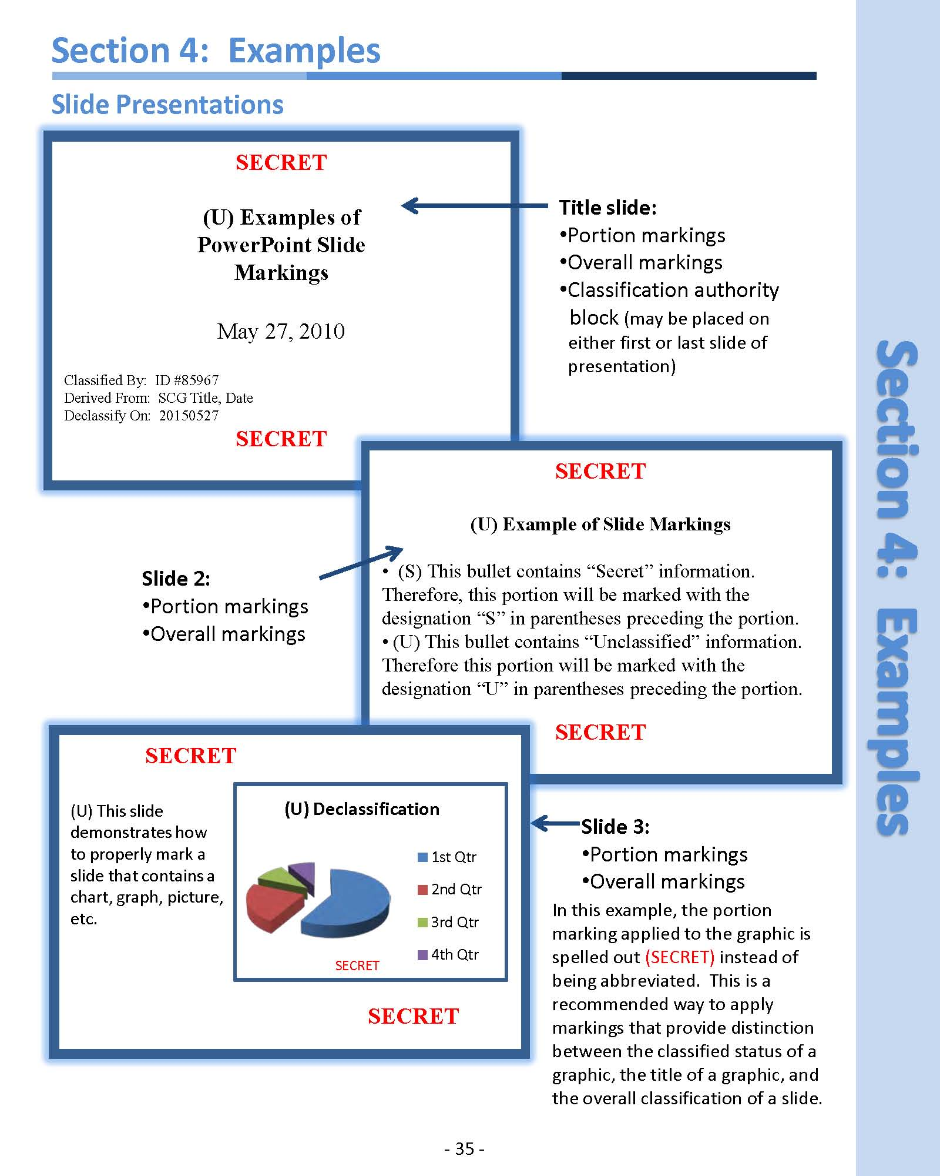

UNCLASSIFIED

FOR TRAINING PURPOSES ONLY

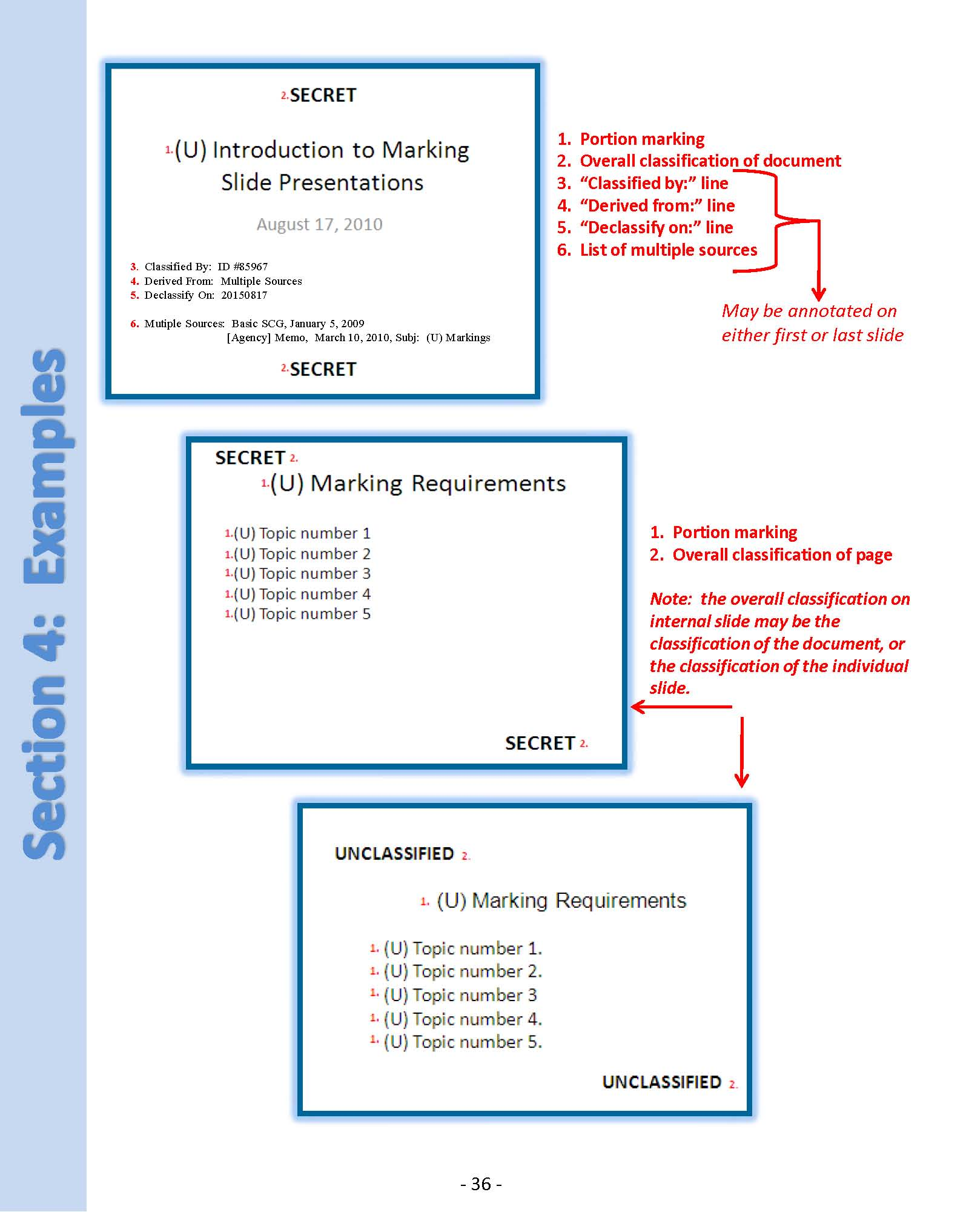

UNCLASSIFIED

FOR TRAINING PURPOSES ONLY

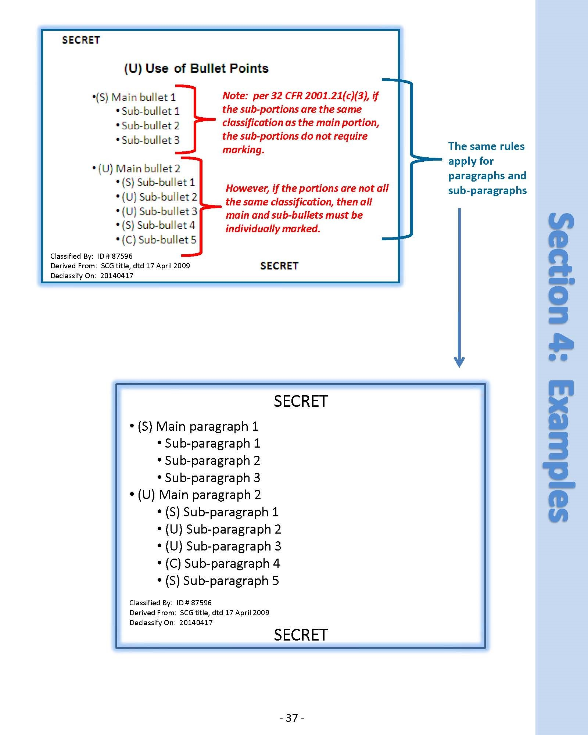

UNCLASSIFIED

FOR TRAINING PURPOSES ONLY

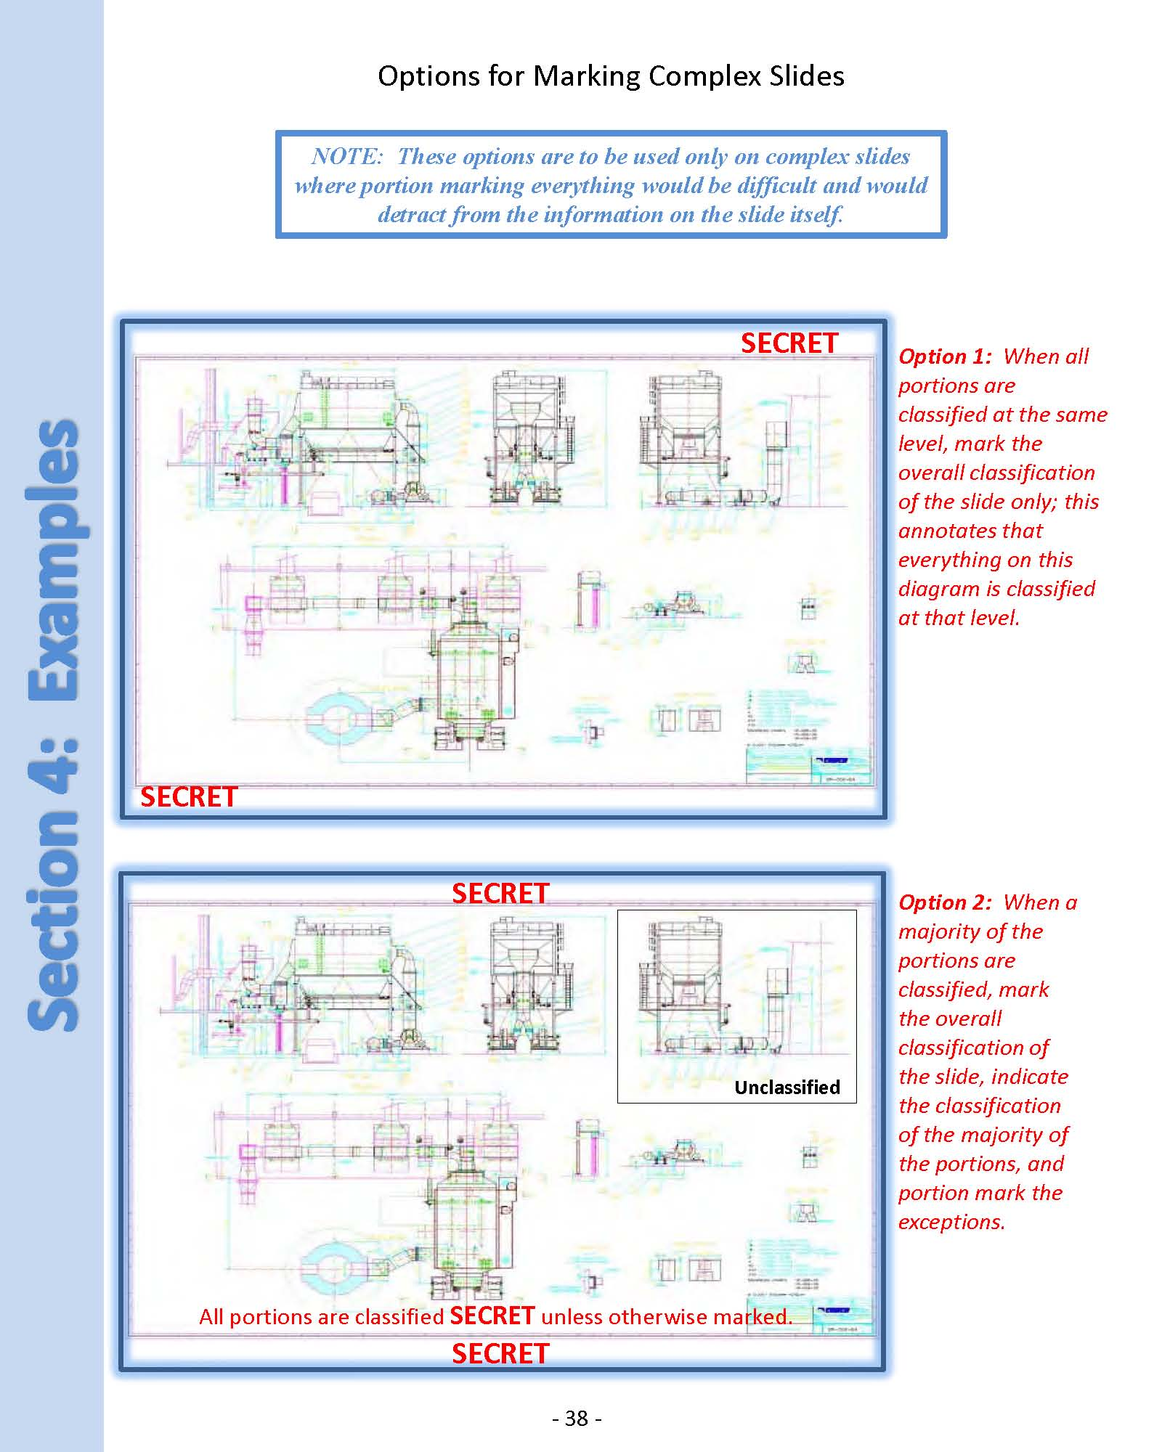

UNCLASSIFIED

FOR TRAINING PURPOSES ONLY

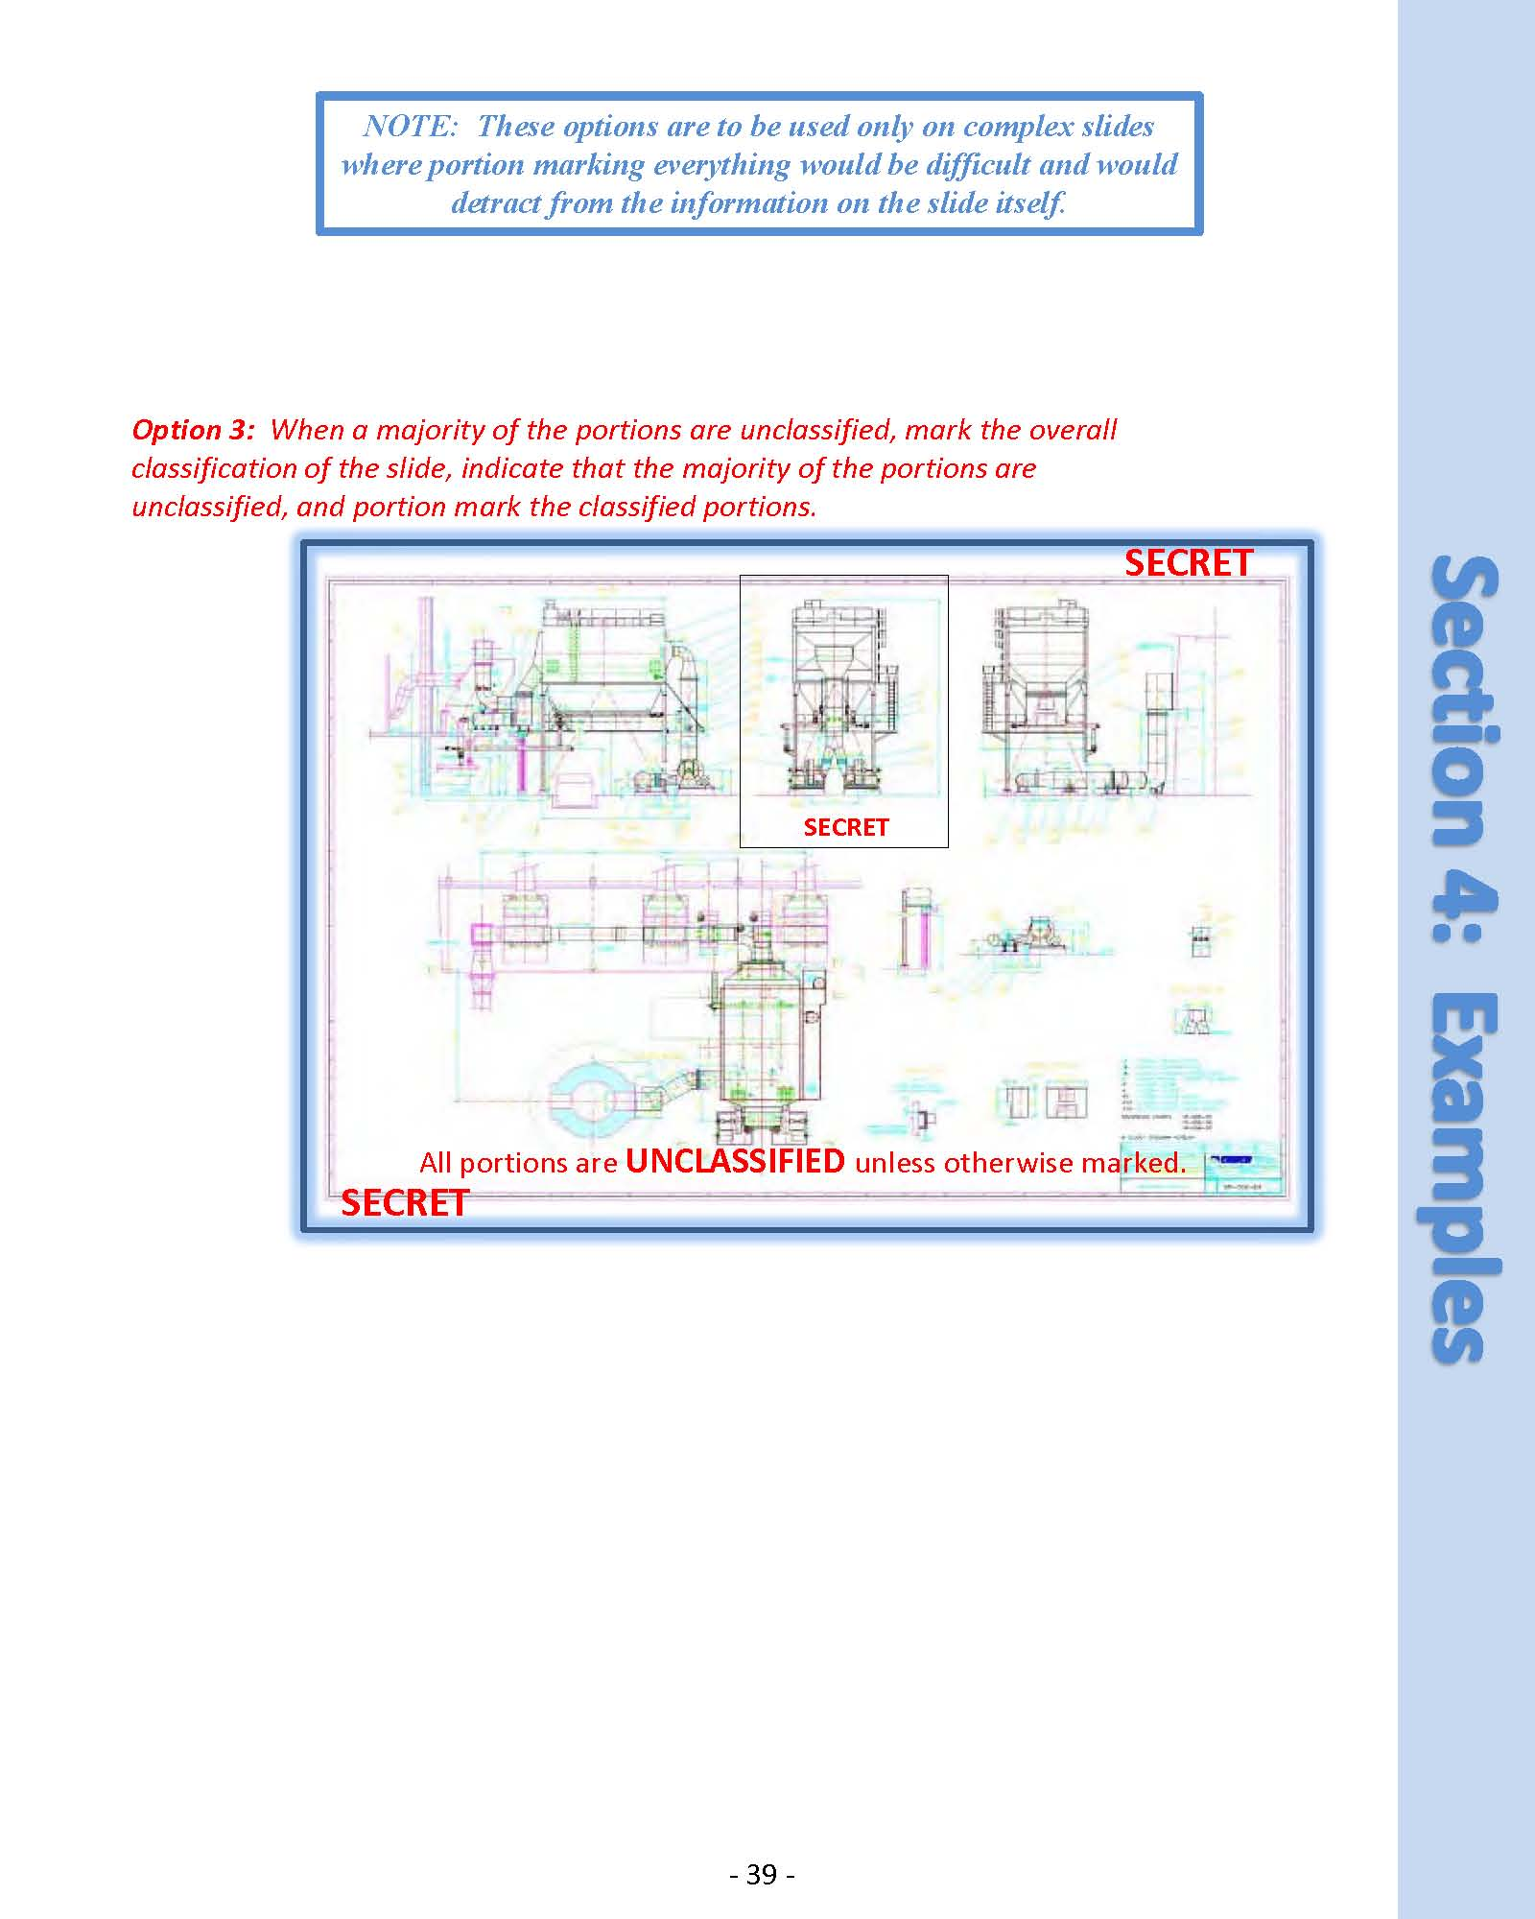

UNCLASSIFIED

FOR TRAINING PURPOSES ONLY

**1.7.6.3 Development of Learning Objectives.** Guidance for developing Learning Objectives is as follows.

Overview:

Learning objectives (LOs) will be based on instructional content. A well-written LO utilizes a clear and measurable behavior that the student must perform.

Rationale of Developing Learning Objectives:

Developing Learning Objectives assist instructors and students in the following manner:

* Facilitates overall course development by encouraging goal-directed planning
* Drives curriculum planning for the revision of existing instruction
* Informs students of the standards and expectations of learning
* Clarifies the intent of instruction and guides the formation of instructional activities
* Provides a framework for evaluating student understanding throughout instruction
* Provides evidence of student competency to be utilized for accreditation
* Provides content for the development of assessments
  + Identifies the types of evidence that students need to produce to demonstrate competency
  + Serves as an implicit contract between the instructor and the student
  + Provides a summative evaluation of student understanding
  + Creates a framework for evaluating the overall effectiveness of an educational period

Guidelines for Writing Effective Learning Objectives:

Effective LOs identify specific, expected student behavior. Each LO should state observable, behavioral outcomes and state what the student will be able to do at the conclusion of the instructional period.

Learning Objectives should be SPECIFIC AND TARGET ONE EXPECTATION or aspect of understanding. Since students will utilize the LOs to guide their performance, be sure to use specific terminology that has limited interpretations to ensure that all students share the same interpretation of these expectations.

When writing the objective in performance terminology, the selection of an EFFECTIVE ACTION VERB is of utmost importance.  The use of a clear, targeted verb provides directions about the expectations of student performance at the completion of instructional activities.  As the verb provides the desired direction of emphasis, it is important to choose a verb that is focused and targets a level of performance appropriate for the course. It is essential to clarify to what extent a student must perform. For example, there is a significant difference in the depth of response between the words LIST, which implicates a mere restating of terms either verbally or in a written list form, and DISCUSS, which indicates a depth of understanding and an in-depth narrative about a topic or concept. Thus, the verb also indicates a degree of accuracy, a quantity of correct responses, or some other type of measurable information.

Quick Tips for Improving Learning Objectives:

* Learning objectives have two parts:  an action verb and a content area.  Utilize the action verb to specify the desired student performance followed by a specific description of the course-specific content target.
* Keep statements short and focused on a single outcome.  This allows instructors to determine whether or not an objective has been met without having to distinguish between partial completion or success.
* Include complex or higher-order learning objectives when they are appropriate.  Most instructors expect students to go beyond memorization of facts and terminology; learning objectives should reflect instructors’ expectations for student performance.
* Utilize learning objectives as a basis for course preparation.
* Learning objectives should match instructional strategies and assessment requirements.
* Avoid using verbs that are difficult to measure objectively.  Use active verbs that describe what a student will be able to do once the learning has occurred.

The following verbs are difficult to assess, thus should be used with caution:

* Know
* Comprehend
* Understand
* Appreciate
* Familiarize
* Study
* Be aware
* Gain knowledge of
* Cover
* Learn
* Realize

Levels of Cognition

Identifying behavioral goals requires an instructor to determine the depth of cognition expected during and after the period of instruction. These levels of cognition are broken down into a hierarchy of cognitive tasks and are outlined in six categories. The amount of conceptual knowledge and integration increase as levels increase.  Generally, instructors will develop learning objectives to target a range of levels of activities and assessment.

|  |  |  |
| --- | --- | --- |
| DOMAIN | EMPHASIS | RELEVANT VERBS |
| Cognitive | Knowledge | Recall, identify, recognize, acquire, distinguish, state, define, name, list, label, reproduce, order |
| Cognitive  Tasks advance in cognitive complexity and integration | Comprehension | Translate, extrapolate, convert, interpret, abstract, transform, select, indicate, illustrate, represent, formulate, explain, classify, comprehend |
| Cognitive | Application | Apply, sequence, carry out, solve, prepare, operate, generalize, plan, repair, explain, predict, demonstrate, instruct, compute, use, perform, implement, employ, solve |
| Cognitive | Analysis | Analyze, estimate, compare, observe, detect, classify, discover, discriminate, explore, distinguish, catalog, investigate, breakdown, order, determine, differentiate, dissect, contrast, examine, interpret |
| Cognitive | Synthesis | Write, plan, integrate, formulate, propose, specify, produce, organize, theorize, design, build, systematize, combine, summarize, restate, argue, discuss, derive, relate, generalize, conclude, produce |
| Cognitive | Evaluation | Evaluate, verify, assess, test, judge, rank, measure, appraise, select, check, determine, support, defend, criticize, weigh |

Examples of well-written Learning Objectives**:**

* **State** the tactical missions of the Low Altitude Air Defense Battalion
* **Define** Rapid Ground Refueling (RGR)
* **List** the six functions of Marine Aviation
* **Identify** the motors, warheads, and fuzes currently employed by the AH-1W
* **Describe** maintenance and troubleshooting procedures
* **Explain** how ABGD integrates into RAS
* **Develop** an Air Base Master Plan
* **Assist** in reactive weaponeering to the extent that aircraft with the correct capability are sent to appropriate targets
* **Generate** weather criteria that dictates changes in routing for good weather and foul weather routing

**1.7.6.4 Multimedia naming conventions**

The purpose of this portion of the manual is to describe the process of labeling multimedia items. The courseware folder structure on NIPR and SIPR houses associated media. It allows for ease of use by Fleet instructors. Standardization of media nomenclature will ensure media will further support instructional content.

Naming conventions of media per Academic Policy is as follows:

**UNCLASSIFIED Media**

(U) Slide title

*Example:*

(U) Timeline.wmv

**CLASSIFIED Media**

(Classification of media) Slide Title

(SNF) Slide Title (SRELFVEY) Slide Title

(S) Slide Title (SRELNATO) Slide Title

(SRELUSAAUSGBR) Slide Title (SRELISAF) Slide Title

(SRELACGU) Slide Title (C) Slide Title

|  |  |
| --- | --- |
| CLASSIFICATION Abbreviations | |
| Abbreviation | Classification |
| SNF | SECRET (NO FOREIGN) |
| S | SECRET (US ONLY) |
| SRELUSAAUSGBR | SECRET REL TO USA, AUS, GBR |
| SRELACGU | SECRET REL TO USA, AUS, CAN, GBR, ACGU |
| SRELFVEY | SECRET REL TO USA, AUS, CAN, GBR, NZL or REL TO USA, FVEY |
| SRELNATO | SECRET REL TO USA, NATO |
| SRELISAF | SECRET REL TO USA, ISAF |
| C | CONFIDENTIAL |

*Example:*

(SRELACGU) 20mm.wmv

Regarding media slides on presentations without slide titles, the standard is to either create a placeholder title on the slide and use the above naming convention, or title it appropriately, such as the following:

*Example:*

(U) Intro Video

(S) Conclusion Video

**1.8 Instructional Standards.** Instruction and instructional techniques will be professional and based on theory and best practices.

**1.8.1 Murderboards.** Instructor lecture evaluations, known as *“Murderboards,”* are an essential part of the instructional standardization process within MAWTS-1. The purpose of this section is to publish the guidelines and standards for the critique of the lectures. The murderboard concept is meant to serve as a tool to provide constructive feedback and enhance professional development. Murderboards allow for content and format standardization, they eliminate unnecessary overlap between lectures, and most importantly *verify the MAWTS-1 IP*’s *instructional abilities and ensure professional delivery of relevant material.* Murderboards will be held in the venue in which the class will be presented with the instructor in the uniform he/she will be teaching in. Murderboards are the cornerstone of the MAWTS-1 Academic Program.

**1.8.1.2 Murderboard Standards**. A murderboard is divided into three parts: content, presentation, and media. The focus of the content portion will be to ensure that the information is current, accurate, and reflects the MAWTS-1 interpretation of doctrine and current and cutting edge TTPs and technologies. The instructor presentation will be critiqued with evaluators appraising the conduct, mannerisms, and communication skills of the instructor. The final portion of the murderboard will be an evaluation of the quality of the media (slide composition, misspelled words, etc.)

The following situations require a murderboard:

* Any new instructor teaching a class
* Any new class
* Any class with a significant change in content (estimate 20% or more content change) as determined by the instructor or the CRC.
* Any class that received substantial (20% or more) negative critiques by the WTI students and is determined by the CRC to require a murderboard
* Any class in which student critiques identified incorrect information or TTPs being passed
* As directed by the CRC or the CO

**1.8.1.3 Murderboard Scheduling.**  Murderboards will be scheduled in accordance with the WTI milestones. The Academics department will schedule all generic murderboards. Potential instructors must be identified the year prior a change in instructor. Generally, murderboards occur the Friday prior to Second Freeze. This allows time for any identified items, regarding course revision or an additional murderboard, to occur prior to Third Freeze.

Individual departments are responsible for the scheduling and execution of common and specific murderboards.

**1.8.1.4 Murderboard participation and Generic Composition.** Generic Murderboard Composition. Attendance will include members of the Curriculum Review Committee (CRC).

**1.8.1.5 Common and Specific Murderboard Composition.** The composition of common and specific murderboards is at the discretion of the appropriate department head. For common classes taught to more than one department, composition will be determined by concurrence from all participating department heads. At a minimum, it is recommended that representatives from all departments and divisions whose students are scheduled to receive a period of instruction attend the murderboard.

**1.8.1.6 Murderboard Evaluation.** Conduct, Evaluation, and Feedback. For murderboards only, page numbers will be displayed on each slide of a PowerPoint presentation to enable easier critique by evaluators. The page numbers will be removed prior to delivery to students. At the conclusion of the murderboard, each evaluator will give a brief oral summary of their critique. Murderboard critiques utilize a standard MAWTS-1 murderboard form that has been developed for the purpose of evaluation (follows). The Academics representative will provide critique forms for the murderboard for Generics; Commons and Specifics murderboard forms will be provided by Academics upon request. Written critiques will be collected by the Academic representative, reviewed, scanned, and archived in the share folder at: T/ACAD/5. Instructor Folders. Copies of the written critiques will be delivered to the instructor within 24 hours of the murderboard. The Academics Department Head will be informed when department common and specific murderboards are complete.

For reference, a copy of the academics portion of the murderboard evaluation instrument follows. The Academic Department members attending will receive a form in which items relating to delivery and instructional techniques will be evaluated. ISDs will validate the test items housed in Question Mark Perception as compared to the instruction and instructional products provided during the murderboard. The department/division’s instrument has response items relating to relevancy to their department/division, as well as responses involving the integration of the subject matter for their particular department/division.

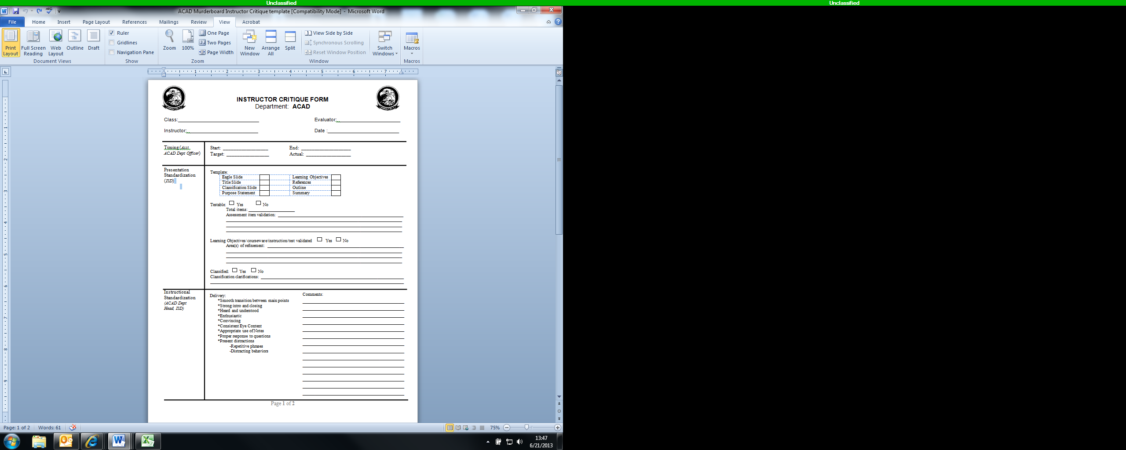

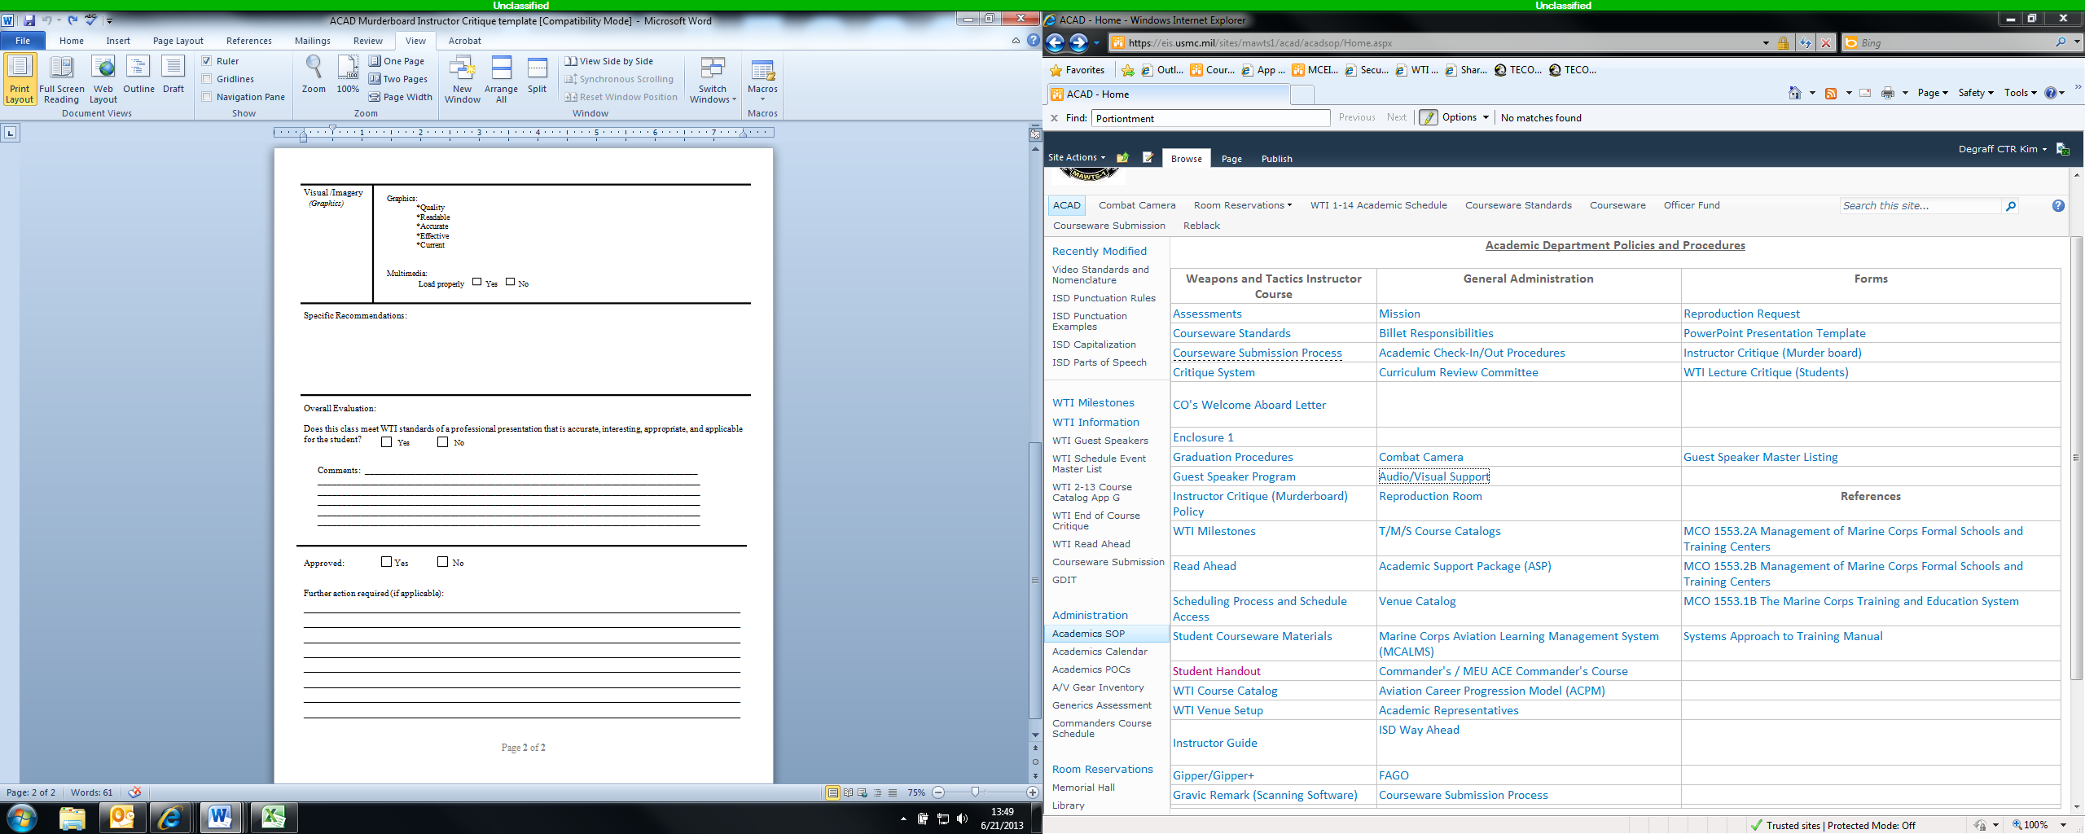

**1.8.1.7 Remediation**. If it is determined that an instructor is not adequately prepared to present the course to WTI students, an additional murderboard will be scheduled with the appropriate department; the Academic department for generic lectures and individual departments for common and specific lectures. The instructor will meet with the department-specific ISD and discuss means of improving performance or instructional content. If an instructor fails two murderboards, the CRC will recommend to the CO possible ways forward. This might include scheduling an additional murderboard or possibly assigning another instructor to the course.

**1.9 Evaluation Policies, Design, and Products.** MAWTS-1 continuously monitors and evaluates instructional programs in order to determine the effectiveness of those programs, facilitate high quality student output, and maximize use of limited resources.

The purpose of MAWTS-1 policies, design guidance, and the outline of products is to provide guidance for a systematic and standardized approach to assessing the effectiveness, efficacy, and efficiency of MAWTS-1 instructional programs. This will be accomplished through the application of process and procedures providing visibility through the collection, analysis, and interpretation of instructional evaluation data. Success will be measured through implementation of a systematic program to evaluate instruction, identify training deficiencies, document evaluation results, and make recommendations to modify, continue, or terminate procedures and instructional programs.

**1.9.1 Examinations.** Examinations are a critical part of the learning process and will be used throughout the WTI course. They are intended to display mastery of the subject matter tested. Although examinations are typically associated with a written test, they can take many forms. This might include written or oral exams, presentations, practical exercises, and hands-on applications. Written exams can take several forms, to include multiple choice, fill in the blank, true/false, and essay. Practical application takes place in the flight phase of WTI. Other exam mediums might be applied in the academic phase.

**1.9.2 Academic Performance Standards.** In all cases, the minimum mastery level at MAWTS-1 is 80%. An academic examination failure will be routed to the appropriate Department Head and the CO. Upon failing an examination, a student will receive remediation; one option is for a retake version of the examination to be administered. Upon failing an examination twice, at the discretion of the CO, the student may be removed from the course.

**1.9.3 Creating an exam.** The following guidelines are provided for consideration when creating an exam. Learning objectives form the framework from which exam items should be created. MAWTS-1 exams should be a combination of the formats listed in the following paragraphs.

**1.9.3.1 Fill in the blank and true/false.**  Fill in the blank and true/false exams test to the lowest level of comprehension, rote memorization. There is clear benefit to this in many cases; however, this format should not dominate a MAWTS-1 exam.

True and false questions provide an adequate method for testing learners when two or more distracters cannot be constructed for a multiple-choice question or to break up the monotony of a long test. Multiple-choice questions are generally preferable as a learner who does not know the answer has a 25 percent chance of correctly guessing a question with four choices or approximately 33 percent for a question with three choices. With a true-false question their odds are better with a 50 percent chance of guessing the correct answer.

When developing, true and false exam items:

* Use definite and precise meanings in the statements.
* Do not uses statements directly from books or notes.
* Distribute the true and false statements randomly in the test instrument. (Clark, 2013)

**1.9.3.2 Multiple Choice**. The multiple choice question is flexible and effective for measuring associations, understandings, application of principles, and/or the ability to interpret data. Only the ingenuity and talent of the instructor limit the versatility and effectiveness of the question.

Rules of thumb for creating multiple choice questions:

* Ensure there is one and only one correct answer.
* Questions designed to measure understanding, insights, or ability to apply principles should be expressed in novel terms. If the situation used very closely follows the examples presented in the outline or class, the possibility of a correct answer being based on rote memory is very real. Try to rephrase the situation from which the concept was originally presented.
* Multiple choice questions require the inclusion of four or five possible solutions; one correct answer, and three to four distracters.
* The selection of distracters should ensure the correct response is identified only through the sound understanding of the material emphasized in the learning objectives, and not due to the elimination of inane solutions.
* Solutions characterized by "All of the above", or "None of the above", may be included in some cases, but are not desired as a rule.

**1.9.3.3 Essay.** An essay is perhaps the best indicator of true mastery of a concept, system, technique, or principle. Essay questions or essay exams require a concerted, standardized effort to grade.

**2.0 MAWTS-1 Evaluation Products.**

**2.1 Exam Question Bank**. The Academics department is responsible for maintaining a question bank of a minimum of three exam questions per learning objective.

Question Mark Perception (QMP) is a test generating program that houses Generics, some Commons, and some Specifics exams. It resides on local computers specific for its use and on the internal Wi-Fi server. Any exam not currently in the system can easily be added. The benefits are as follows:

1. Consistency
2. Randomizing
3. Security
4. Central location
5. Ease of use

**2.2.1 Inventory Exam.** The inventory exam is a 50 question, closed book multiple choice and true or false exam. It is used to determine student preparation for WTI and covers a broad level of educational competencies. Additionally, it may serve to highlight potential areas needing additional exposure. The exam is generated from items in QMP. Exam items are validated and is maintained by the Academics department. Two versions of the exam are distributed in an effort to increases test integrity. The proctoring of the Inventory exam occurs on day 1 of WTI and is administered by the Academics Department. They collect, collate, process, analyze, and report results. Mastery level is 80%.

Evaluation of test item mastery level after testing concludes is achieved by the following method:

a. All test items are evaluated. Any test item receiving a 50% or below mastery level will be further analyzed for validity.

1. Test items receiving a 50% or below mastery level may be considered as invalid and any answer selection, correct or incorrect, will be counted as correct.

2. Test items receiving a 50% or below mastery level may be considered as valid and all answer selections will be recorded as marked.

The completion of the Read-Ahead is also monitored in conjunction with academic performance on the Inventory Exam.

1. MCALMS reports are generated and distributed from ACAD on a weekly schedule between 2nd and 3rd Freeze and daily during 3rd Freeze. The report includes the length of time and mastery levels on the Read-Ahead Interactive Courseware modules.

**2.2.2. Generics Exam**. The Generics Exam may be a multiple choice, true or false, fill in the blank, and short answer exam or a combination of the previous. It allows the student to demonstrate mastery of generic academic WTI material. Successful completion fulfills the prerequisites for continued training in Common Academics.

Generics exam items are created and reviewed for relevance and accuracy by the Generics instructor prior to each WTI course and must be complete by the end of 2nd Freeze. As all Murderboards should be complete by this time, all assessment items should also be validated.

The exam is generated, administered, graded, and analyzed by the Academics department. Two exams are generated; one for students that are attending from other countries, an S//REL version, and one for all other students, an S//NOFORN version. Two versions of each exam exist to allow for exam and student integrity.

Students not able to reach the 80% mastery level are remediated during the Generics week with a retake exam that follows a similar format.

**2.2.2.1 Exam Distribution process:**

1. Exams are distributed by the Academic representatives. Sentries are placed at the doors, if required.
2. Students are provided with a test document and an answer document in a similarly numbered folder.
3. Students provide input on the answer document.
4. Folders are returned to Academic representatives at their completion of the exam and/or at the end of the testing session.
5. Academics representatives ensure that both documents are present in the respective folders and that all of the associated numbers are present and accounted for.
6. At the concluding of the testing session, the testing location will be determined to be free of additional testing folders/items.
7. Academics processes and analyzes the outcomes for the academic record using a scanner and data analysis software (Remark).
8. Final analysis results are reported to Department Heads for distribution.

**2.2.3. Common & Specific Exams**. Common and specific exams are designed for student to demonstrate mastery of common and specific material. Common and specific exams are generated, maintained, administered, graded, and analyzed by the departments and division unless there is an ACAD assistance request. Successful completion fulfills the prerequisites for continued training in specific academics or the flight phase, respectively.

**2.3 Critiques.**

**2.3.1 Student Critiques.** The academic critique system used at MAWTS-1 is designed to acquire feedback from WTI students on the relevance and quality of instruction. Each student is provided with a critique sheet for every generic and common class they will attend and are expected to complete it by the end of each workday.

The critique system procedures are as follows:

1. Each student receives a user name and password to access QMP.
2. The Academic Department, using the academic schedules, will schedule critiques. Instructors will prompt students at the end of the course, using a “Questions / Critique” slide added to the end of the presentation, to complete the critique.
3. Academics will then generate a comprehensive report recording specific recommendations and will post results in the following location, in each respective instructor’s folder: T/ACAD/5.Instructor Folders
4. The Academic Department analyzes the data and includes it in the comprehensive data analysis in the “Academics After Action Report” that is distributed during Hotwash.

For the current survey, please reference page 51.

**2.3.2 WTI End of Course Critiques.** End of course critiques are intended to provide the CO with information on the quality of the WTI course as a whole. The information is analyzed and used by the Operations Section (S-3) using an Internet-based survey. Data collected is then combined into the EOCC report that is then distributed at Hotwash and reported to the CO. The process is as follows:

1. The students complete the survey and reports the completion to their Division Head. S-3 will analyze and archive data.
2. S-3 enters the information from the critiques into the database and creates a report of the collected data. The report will be forwarded to the CO for his use.

**3. Guest Speakers.** To enhance the WTI course, guest speakers are solicited to relate unique experiences or impart specific technical knowledge that **is not resident** within the instructors at MAWTS-1. Examples are foreign defectors, POWs, active duty and retired military personnel, and dignitaries with combat experience. Guest speaker requests and directions for filling them out can be found in the Academics folder on the X-drive and must be filled out completely and routed through the Academics department.

**3.1 Funding.** Guest speakers may fund themselves, or may be funded by MAWTS-1. Guest speakers requiring funding from MAWTS-1 can be accommodated in two manners. For military personnel, MAWTS-1 can provide funding data, which will be used by the individual’s administrative support to write their orders, purchase airlines tickets as required, and reimburse them for travel expenses. In this case the guest speaker would simply file a travel claim at their parent unit upon completion of TAD. Guest speakers that are not able to generate orders (primarily foreign, civilian, or retired guest speakers) will receive invitational travel orders from MAWTS-1. In this case travel accommodations must be made through SATO (1-800-764-8430)via MAWTS-1 and the travel claim must be filed at MCAS Yuma. Individual departments must budget for specific and common guest speakers. The Academics Department will budget for generic guest speakers.

**3.1.1 Guest Speaker Responsibilities**

**Generic Guest Speakers**. The Academics Department will perform all of the administrative support functions, to include the guest speaker request, travel and lodging arrangements, sponsorship and funding for generic guest speakers.

**Common and Specific Guest Speakers**. Individual departments are responsible for submitting guest speaker request to Academics complete with travel and lodging arrangements in accordance with the WTI milestones. Department heads will ensure an appropriate sponsor is assigned to all guest speakers.

Student Response Survey (SRS)

Lecture Title: ______________________________________

Instructor: _______________________________________

Student Name:______________________________________

|  |  |  |  |  |  |  |  |
| --- | --- | --- | --- | --- | --- | --- | --- |
| Community (Mark ONE only) | | | | | | | |
|  | AH-1 |  |  | EAD |  |  | LET |
|  | AGS |  |  | F/A-18 |  |  | MMT |
|  | AOD |  |  | F-35 |  |  | MV-22 |
|  | AV-8 |  |  | GCD |  |  | UAS |
|  | C3 |  |  | INTEL |  |  | UH-1 |
|  | CH-53 |  |  | KC-130 |  |  | ACAD only |
|  | Other |  |  | AAMOC |  |  | MEOC |

*Please indicate your level of agreement with the following statements*:

|  |  |  |  |  |  |
| --- | --- | --- | --- | --- | --- |
|  | Not observed | Strongly Disagree | Disagree | Agree | Strongly  Agree |
| The course content was accurate. |  |  |  |  |  |
| The course content was relevant to my occupational specialty. |  |  |  |  |  |
| The instructor effectively presented and clearly explained the content. |  |  |  |  |  |

Provide comments relating to the accuracy, relevancy, and effectiveness of this course and/or the instructor.

|  |  |  |  |  |  |  |
| --- | --- | --- | --- | --- | --- | --- |
| ***Please rate the following:*** | **Poor** | **Fair** | **Satisfactory** | **Good** | **Excellent** | **Outstanding** |
| **How would you rate the overall effectiveness of this period of instruction?** |  |  |  |  |  |  |

Additional

Resources

Learning Theory Matrix

|  |  |  |  |
| --- | --- | --- | --- |
| **Perspective** | **Behavioral** | **Information Processing** | **Constructivist** |
| **Background** | Early 20th century  B.F. Skinner – his ideas on Operant Conditioning largely contributed this perspective.  Developed as a reaction to the study of mental phenomena. | Mid 20th century  George Miller – provided two ideas that are fundamental to this perspective: 1. short-term memory can only hold 5-9 chunks of meaningful information. 2. The human mind functions like a computer – taking in information, processes it, stores and locates it and generates responses to it.  Developed as a reaction to behaviorism. | Later 20th century (although ideas of constructivism have existed prior to the 20th century - Dewey, Piaget, Bruner, and Vygotsky)  Represents a collection of theories including - generative learning, discovery learning, and situated learning..  Ideas of constructivism come from cognitive psychology, developmental psychology, and anthropology. |
| **Definition** | Learning occurs when new behaviors or changes in behaviors are acquired as the result of an individual’s response to stimuli. | Learning is a change in knowledge stored in memory. | Learning is the process where individuals construct new ideas or concepts based on prior knowledge and/or experience. |
| **Principles** | The influence of the external environment contributes to the shaping of the individual's behavior.  The environment presents an antecedent that prompts a behavior.  Whether the behavior occurs again is dependent on the consequence that follows it. | Governed by internal process rather than by external circumstance (behaviorism).  Process of selecting information (Attention), translating information (Encoding), and recalling that information when appropriate (Retrieval). | Individuals construct knowledge by working to solve realistic problems, usually in collaboration with others.  Learning as a change in meaning constructed from experience.  Individual interpretation of experience vs. objective representation (information processing perspective) |
| **Applications for Instruction** | 1.State objectives and break them down into steps  2 Provide hints or cues that guide students to desired behavior.  3 Use consequences to reinforce the desired behavior. | 1. Organize new information.  2. Link new information to existing knowledge.  3 Use techniques to guide and support students' Attention, Encoding, and Retrieval process. | 1.Pose "good" problems - realistically complex and personally meaningful.  2 Create group learning activities.  3 Model and guide the knowledge construction process. |

The Systematic Approach to Training (SAT): Methodology and Main Phases

Systematic Approach to Training Methodology

The Systematic Approach to Training or SAT is a methodology for managing training programs. It is an orderly; logical approach to determining what people must know and do at a particular job or in a specific profession. The systematic approach to training ensures that people are prepared for their work by having the necessary knowledge, skills, and attitudes to do their job. SAT is performance based and competency driven. It is concerned with on the job performance. SAT begins with identifying people's work related needs. It ensures training is delivered properly; the student learns what is important; and the student is competent to be assigned to work. The systematic approach to training uses constant evaluation of the training program to ensure it is meeting the needs of the students and the operating forces. SAT is always a combined effort between trainers and experts from operational organizations. Managers, supervisors, and subject matter experts (SME) from such elements as operations, maintenance, and training sections, play an important role in the implementation of the systematic approach to training here at Communications School.

Combined Effort

The combined effort between training sections (SMEs) and curriculum developers is a “linchpin” to the successful implementation of SAT. Instructors/Instructional Specialist/Curriculum Developers provide expertise in the SAT methodology and process. They apply the systematic approach to training to meet the needs of the organization. However, the curriculum developer/instructional specialist cannot do SAT alone. Experts from instructor groups provide the expectations and work requirements of the group. They identify the work that will be done and the standards against which students will be judged. Instructor groups with help from curriculum developers determine the knowledge, skill, and attitudes that must be mastered by students.

SAT Outcomes

With the systematic approach to training, Communications School ensures that important topics and skills are identified, proper learning methods are used, training material is useful to students, and that students can perform work as expected when they are assigned to work. The systematic approach to training ensures the training program supports the real customer’s (Operating Forces) needs for human performance. It ensures Marine Communicators are prepared and capable to do their occupation.

SAT Main Phases

There are five main phases in the systematic approach to training. They are Analysis, Design, Development, Implementation, and Evaluation (ADDIE).

Analysis

The first phase in SAT is analysis. The first questions that necessitate asking are:

"Is there a need for training?"

"If something is wrong, is it caused by a performance problem that training will fix?"

Make sure training is required. Then analyze to determine what training should be prepared. In the analysis phase the duties of a job are identified and listed. The tasks that must be completed to accomplish the duties are analyzed. Often we find tasks that are so large that we must break them into smaller parts or multiple tasks. From the tasks, we determine the knowledge, skills, and attitudes needed to perform the task successfully. Tasks are reviewed and characterized by difficulty, importance, and frequency to help determine whether training is required prior to performing the task. These groupings also help us select tasks on which communicators will receive continuing training throughout their careers. A more difficult task would have training associated with it. An easy task may not have formal training (i.e. school), but may only have a procedure for the Marine to follow. Tasks that are important to safety or operation would have training. Routine tasks with no impact on safety or operation may not have training. Infrequently performed tasks usually have training completed just before they are to be performed (just in time training, a role the CTCs play in the training continuum). The involvement of training sections is important to the analysis process. Curriculum developers should not be expected to know everything about a job. They are not expected to set the performance standards for the training group, rather they serve to facilitate and integrate the SME’s knowledge into the SAT process. This is the responsibility of the instructor group. The instructor group must provide the standards and their expectations for student performance to the curriculum developers during the analysis phase. The curriculum developer will use these standards for successful performance of work to create the standards for passing the course. During the analysis phase, SME will attempt to identify the knowledge and skills of future students (Target Population Description). This will allow the course to be designed to meet their learning needs.

The outcome of the analysis phase is a task analysis that lists the tasks that are performed to accomplish the duties of a position and the knowledge, skills, and attitudes necessary to perform the tasks. These become the basis for the design of the course and for writing the student learning objectives.

Design

The design phase is really a decision making phase. In the design phase, we complete three important activities:

Decide what the student will learn in the class and how that learning will transfer to the job. (From this activity, student-learning objectives are written.)

Decide what will be taught and the instructional methods to be used to teach by.

Decide how the student will demonstrate competency to do the required work and develop an examination plan to test the student's competency.

Learning objectives are often broken into two types*: (Enabling Learning Objectives are not used at MAWTS-1)*

Terminal Learning Objectives-explain what the student must be able to do after completing the training. (Verbatim from the Training and Readiness Manual)

Enabling Learning Objectives-specific learning objectives tell what knowledge, skills, and attitudes must be displayed during class.

They are written in words a student can understand. There should be no surprises for students, instructors, or supervisors. Students are given the learning objectives at the beginning of class so they know exactly what is expected for them to learn. The learning objectives are based upon the results of the analysis phase. The student examinations are based upon the learning objectives.

The design phase also determines what will be taught and how it will be taught. In this phase, we select the instructional technology and the media to be used. The instructional technology usually includes some combination of the following: hands on practice (PA), lecture (platform instruction), overhead (power point), video tape, training equipment (simulators), computer training (CBT,WBT,IMI), pictures, models, student reading, self-study, or on the job training. It is important to decide how the student will practice the skill to be learned. The key is to align the training with real world performance or as near possible.

During the design phase, the training section examines existing training material to determine if material already exists to teach these learning objectives. If material is not available, the SME considers whether to develop new material or to purchase material from an outside supplier. Using the learning objectives as the standard, the SME develops an examination plan to determine if the student is competent concerning the course material. This plan states the learning objectives to be tested and the number of questions relating to each learning objective. Instructors determine the type of question and difficulty level of the questions. An examination table of specifications is written to guide the actual writing of questions in the development phase. This is one of the most difficult tasks—constructing test items that accurately measure the expected outcome.

Development

In the development phase, the training design is prepared into training material. Training materials for instructor and students are written or purchased. These materials could include lesson plans, student handouts, videotapes, training aids, or other material (MLF items).

Examination questions are written as required in the examination table of specifications from the design phase. Questions are assembled into student exams as needed.

Implementation

In the implementation phase, the instructor teaches and the student learns. Although this is the phase that most people think of as "training”, it is the easiest phase to perform. The material written during the development phase is used to implement the decisions that we made in the design phase. Instructors also apply the information learned about the job in the analysis phase during implementation. At the completion of the course, the students prove their competency by passing the course “capstone exercise”.

Evaluation (see Kirkpatricks’s Evaluation that follows)

Evaluation is usually listed last. However, evaluation is done throughout the SAT process. Evaluation is asking, "How are we doing?"

During the other three phase’s trainers do an evaluation to ensure the process is working correctly and to identify improvements immediately. After the training is, completed trainers evaluate the effectiveness of the training through formal or informal Course Content Review Board. They determine if the student is performing on the job as expected. They determine if the training course was useful to the operating forces mission performance. Identifying improvements for the course and improvements for the entire training process is an important part of the evaluation phase of SAT. The best evaluation of training effectiveness is done on the job. We ask students and their supervisors (fleet surveys) if they are properly prepared to do their job.

Conclusion

The systematic approach to training is always attempting to improve performance of our Communications Marines. It is an orderly; logical approach to determining what Marines must know and do at a particular job or in a specific profession and to prepare them to do their job. The systematic approach to training ensures that communicators are prepared for their work by having the necessary knowledge, skills, and attitudes to do their job.

There are five phases in the systematic approach to training: Analysis, Design, Development, Implementation, and Evaluation, our critical vulnerability lies within the design and development phases.

**Test Design Research.** Kirkpatrick’s four levels of evaluation follows.

Reference: Winfrey, E.C. (1999). Kirkpatrick's Four Levels of Evaluation. In B. Hoffman (Ed.), *Encyclopedia of Educational Technology.* Retrieved December 11, 2008, from http://coe.sdsu.edu/eet/articles/k4levels/start.htm

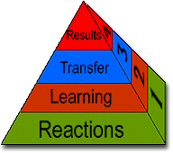

In Kirkpatrick's four-level model, each successive evaluation level is built on information provided by the lower level.

ASSESSING TRAINING EFFECTIVENESS often entails using the four-level model developed by Donald Kirkpatrick (1994). According to this model, evaluation should always begin with level one, and then, as time and budget allows, should move sequentially through levels two, three, and four. Information from each prior level serves as a base for the next level's evaluation. Thus, each successive level represents a more precise measure of the effectiveness of the training program, but at the same time requires a more rigorous and time-consuming analysis.

**Level 1 Evaluation - Reactions**

Just as the word implies, evaluation at this level measures how participants in a training program react to it. It attempts to answer questions regarding the participants' perceptions - Did they like it? Was the material relevant to their work? This type of evaluation is often called a “smilesheet.” According to Kirkpatrick, every program should at least be evaluated at this level to provide for the improvement of a training program. In addition, the participants' reactions have important consequences for learning (level two). Although a positive reaction does not guarantee learning, a negative reaction almost certainly reduces its possibility.

**Level 2 Evaluation - Learning**

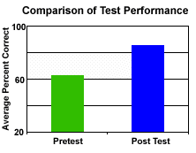

To assess the amount of learning that has occurred due to a training program, level two evaluations often use tests conducted before training (pretest) and after training (post test).

Assessing at this level moves the evaluation beyond learner satisfaction and attempts to assess the extent students have advanced in skills, knowledge, or attitude. Measurement at this level is more difficult and laborious than level one. Methods range from formal to informal testing to team assessment and self-assessment. If possible, participants take the test or assessment before the training (pretest) and after training (post test) to determine the amount of learning that has occurred.

**Level 3 Evaluation - Transfer**

This level measures the transfer that has occurred in learners' behavior due to the training program. Evaluating at this level attempts to answer the question - Are the newly acquired skills, knowledge, or attitude being used in the everyday environment of the learner? For many trainers this level represents the truest assessment of a program's effectiveness. However, measuring at this level is difficult as it is often impossible to predict when the change in behavior will occur, and thus requires important decisions in terms of when to evaluate, how often to evaluate, and how to evaluate.

**Level 4 Evaluation- Results**

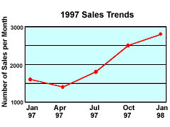

Level four evaluation attempts to assess training in terms of business results. In this case, sales transactions improved steadily after training for sales staff occurred in April 1997.

Frequently thought of as the bottom line, this level measures the success of the program in terms that managers and executives can understand -increased production, improved quality, decreased costs, reduced frequency of accidents, increased sales, and even higher profits or return on investment. From a business and organizational perspective, this is the overall reason for a training program, yet level four results are not typically addressed. Determining results in financial terms is difficult to measure, and is hard to link directly with training.

**Methods for Long-Term Evaluation**

* Send post-training surveys
* Offer ongoing, sequenced training and coaching over a period of time
* Conduct follow-up needs assessment
* Check metrics (e.g., scrap, re-work, errors, etc.) to measure if participants achieved training objectives
* Interview trainees and their managers, or their customer groups (e.g., patients, other departmental staff)

References

Clark, D. (2013) Big Dog & Little Dog’s Performance Juxtaposition. Retrieved from the web June 18, 2013 at: http://www.nwlink.com/~donclark/hrd/isd/develop_test.html

This publication is

# UNCLASSIFIED

All persons handling this information are required

to protect it from unauthorized disclosure

in the interest of the national security of the United States

The handling, storage, reproduction, and disposition of this publication

must be in accordance with executive orders, statutes,

and Department of Defense regulations.

This publication is

# UNCLASSIFIED

All persons handling this information are required

to protect it from unauthorized disclosure

in the interest of the national security of the United States

The handling, storage, reproduction, and disposition of this publication

must be in accordance with executive orders, statutes,

and Department of Defense regulations.